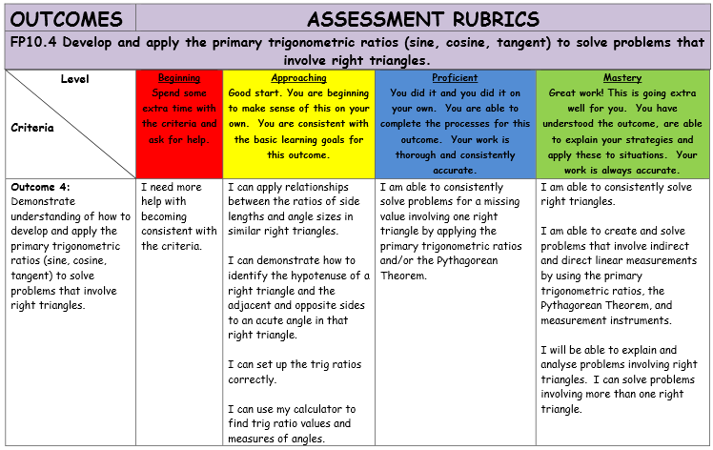

**VIDEO LINKS:**

**You can watch these ahead of my lessons or when you are having difficulties after I have taught the lessons.**

**The Tangent Ratio:** <https://goo.gl/ocVG9J>

**The Sine and Cosine Ratio’s:**

<https://goo.gl/dZcBEi>

**Solving Problems With Trigonometry:** <https://goo.gl/7IhmLb>

**Solving Right Triangles:** <https://goo.gl/grwf6s>

**2.1 The Tangent Ratio**

DO CHAPTER 2 ACTIVITY

In this Unit, we will study Right Angled Triangles. Right angled triangles are triangles which contain a right angle which measures 90˚ (the little “box” in the corner means that angle is a right angle).

[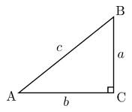](http://www.google.ca/imgres?q=right+angled+triangle&hl=en&sa=X&qscrl=1&nord=1&rlz=1T4SNCA_enCA442CA445&biw=1280&bih=556&tbm=isch&prmd=imvns&tbnid=WbzQkf4HnLfqnM:&imgrefurl=http://en.wikipedia.org/wiki/Right_triangle&docid=FH8MUTlx2ED4HM&imgurl=http://upload.wikimedia.org/wikipedia/commons/thumb/6/6f/Rtriangle.svg/220px-Rtriangle.svg.png&w=220&h=187&ei=3NUcT-e6F4H4gge-sdSuCg&zoom=1)

Skill: Labeling Right Angle Triangles

Quite often, the right triangle will be labeled using letters such as in the triangle above. Capital letters are used to label __________ while small letters are used to label ____________. We also need to be able to label the triangle with words and symbols.

* The Angle: The size of the one angle we want to use to “start” working with. Although we will always be given a “right angle”, that will never be the angle we want to start using as a reference point. It will be one of the other two angles. This angle will have an actual degree size in the corner or it may have a little symbol like this in the corner.

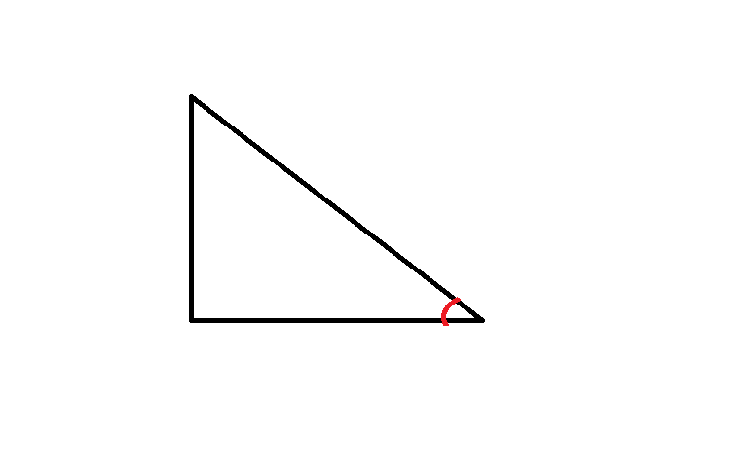

We also use the Greek symbol Ѳ (Theta) in the corner for an angle.

* Hypotenuse: This is the side of the triangle directly across from the right angle (BTW it is always the longest side in a right angle triangle). Always label this side first.

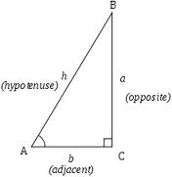

* Opposite: Imagine you are standing in the corner of the triangle where “the angle” is. The side we call “OPPOSITE” is the side that is directly opposite you (but not the hypotenuse).
* Adjacent: The word adjacent means “beside”. If you are standing in the corner where “the angle” is, the adjacent side is the side “beside you” (but not the hypotenuse!)

NOTE: Sometimes the Opposite and Adjacent sides are also called LEGS.

Example: Label the following triangles using the terms from above.





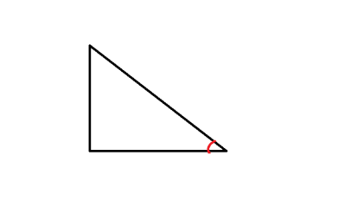

The Greek scientist and mathematician Ptolemy (90 AD – 168 AD) can be credited with establishing much of what we are about to learn regarding Trigonometry in this chapter. What he and his fellow mathematicians found was that if you drew any number of right angle triangles, of any size, certain patterns emerged. For example, if you were to choose a certain degree of an angle and draw different large size and small size triangles with that size angle in the corner, and you were to measure the opposite side and the adjacent side and divide them, you would get the exact same decimal answer for every single one of these triangles. This is because these triangles are Similar Triangles. Similar triangles have all three angles the same size and all three sides Proportional.



What followed was a complete list of all the decimal values that you would get if you were to draw every single sized angle in a right angle triangle and divide the opposite side by the adjacent side. This information became so important and so well used that it soon developed its own name. It is known as the Tangent Ratio.



In simpler terms it usually looks like this:



All of these decimal values have been stored in your scientific calculator. Let’s check:

* First, make sure your calculator is in the correct “mode”. It needs to say Deg, Degree or D at the top. If it says G, Grad, R or Rad, your calculator is in the incorrect mode and needs to fixed!
* Imagine drawing a triangle with a 60˚ angle in the corner. Imagine measuring opposite and the adjacent sides and dividing them using the tangent ratio. Do you think your decimal will be larger or smaller than 1? ________ Larger or smaller than 0.5?__________
* On your calculator press the following buttons: 60 and then tan. You should see 1.74205. If you don’t see that, you may need to press the buttons in the order tan and then 60 for your calculator.
* We always round off this decimal from our calculator to 4 decimal places. This will be 1.7321 (Remember – if the first number we are “getting rid of” is 5 or bigger, we “bump” the one in front of it up one value)

This means that every triangle in the world with a 60˚angle in the corner will have an opposite side divided by an adjacent side that will always turn into 1.7321.

22

4

G

Example: Find the Tangent Ratio for the following Triangles.

8

11

A

Note: The above question will often be asked another way : Determine tan A and tan G

Things to Remember from Last Year:

All three Angles in a Triangle Add to 180˚.

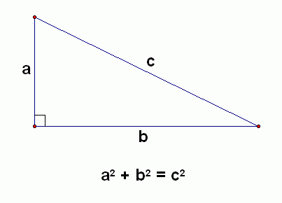

The Pythagorean Theorem:

Example: If tanA = 0.5418, determine the measure of to the nearest degree.

Our calculator has the decimal value for every size angle and it’s tangent. This question is asking us to look at the question from the opposite direction – we are given the decimal that came from dividing the opposite and the adjacent sides. What size was the angle in the triangle?

Use your Grade 9 and 10 skills to “Solve for A” in the question: tanA = 0.5418

* We are going to have to use the SHIFT or the 2nd button in our calculator along with tan to find this answer. You are either going to press the buttons 0.5418 then SHIFT/2nd then Tan Or you are going to press SHIFT/2nd then Tan then 0.5418.
* The calculator shows us _________________ which is the size of the angle with decimals to be very exact. Our question asks us to round to the nearest degree. Our answer will be ________.

Example: Determine the measures of R and S to the nearest tenth of a degree.

R

Ss

Ts

18

11

STEPS:

1. Decide which angle to use as your “Starting Point”.
2. Label your angle, your hypotenuse, your opposite and your adjacent
3. Write down the formula 
4. Fill in the formula with information from your triangle. The “A” will become the letter you chose as your starting point. The Opp will be the length of the opposite side and the Adj will be the length of the adjacent side.
5. Divide your fraction. Leave your answer to 4 decimal places.
6. Use the SHIFT/2nd procedure to find your angle.
7. Our answer is to tenths which means round to one decimal!
8. To find the other angle, subtract the angle you found and the right angle from 180˚

Other Terms to Learn:

Acute Angle: An angle whose size is between 0˚ and 90˚

Angle of Inclination (Also known as Angle of Elevation): The angle measured

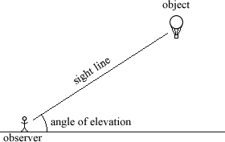between a horizontal line and a line angling upwards.

Example: Ms. C is standing in the courtyard which is 32 feet away from the school and directly across from her classroom. She looks up to the second floor and sees the windows of her classroom which are 16 feet high (and is annoyed when she sees her students hanging out of the windows instead of doing their work). What is the angle of inclination that Ms. C is looking up at? Leave your answer to the nearest hundredth. Please disregard Ms. C’s height (she’s pretty short anyway).

STEPS:

1. Draw a diagram. Be sure that your angle of elevation contains a horizontal line _____ and a line slanting upwards. Put all given numerical information on the diagram.
2. Label your angle, your hypotenuse, your opposite and your adjacent
3. Write down the formula 
4. Fill in the formula with information from your triangle. Divide your fraction. Leave your answer to 4 decimal places.
5. Use the SHIFT/2nd procedure to find your angle.
6. Our answer is to hundredths which means round to two decimals!

2.1 Assignment: Page 75 #3ac, 4ab, 5ab, 8, 10, 11a, 14, 17

7, 12, 13,15, 16, 19, 21

One or more of: 20, 22 or 23

2.2 Using The Tangent Ratio to Calculate Lengths

In this section, we will continue to use right angled triangles and the Tangent ratio. This time we will use the Tangent ratio to find unknown sides in the triangle instead of finding the unknown angle.

Example: Find the length of x to the nearest tenth.

STEPS:

1. Label all of your given information using: angle, hypotenuse, opposite, adjacent.
2. Write down the formula 
3. Fill in the formula with information from your triangle.
4. Use your “Tan” button to find the Tan of the angle. Do not use your shift or 2nd key when you know the number beside the word Tan! Write down the number from the calculator to 4 decimals.
5. Put the decimal on the left side over 1.
6. Cross multiply to find the answer to your unknown side!

22

9DF

x

Example: Find the length of RS to the nearest hundredth. (Note: Sides that are named with two capital letters like RS refer to the side between the angles at R and S)

39

RDF

7

S

T

Example: The following picture shows what the current “Casino Regina” looked like when it was the Union Train Station in Regina in 1911. Let’s assume that the building is 21 m tall. There is a person sitting in the Model T car that is pointed out with the arrow. The person looks up at an angle of elevation of 65˚ and sees a Pigeon sitting on the roof. Using trigonometry, determine how far the car is from the building.

[](http://en.wikipedia.org/wiki/File:Union_station.jpg)

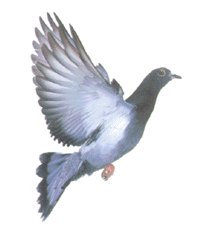

b) If the person in the car wanted to know how far they were from the pigeon along “his line of sight” how could you find that out? Calculate that distance.

2.2 Assignment: Page 82 #3ac, 4ac,5b, 6, 7, 9a, 10, 11, 12, 13, 14

ONE or more of 15 or 16

2.4 & 2.5 The Sine and Cosine Ratio

In this section, we will continue to use right angled triangles and learn two new ratio’s: the Sine Ratio and the Cosine Ratio. We will use these ratio’s to find unknown angle and side measures. We use these formula’s in much the same way we used the Tangent Ratio.



In simpler terms it usually looks like this:





In simpler terms it usually looks like this:



Example #1: Determine the sine and cosine of each angle to the nearest hundredth. (Note: when you are asked to find the sin or cos or tan of an angle it is asking you to use the sin or cos or tan button along with the angle in your calculator – do NOT use your Shift/2nd button!)

a) 62˚ b) 22˚

Example #2: Determine the measure of each T to the nearest degree. (Note: When you are asked to find the size of the angle using sin or cos or tan – you will ALWAYS use the Shift/2nd button on your calculator!)

a) sin T = 0.7834 b) cos T = 0.1279 c) tan T = 1.5834

Example #3: Find the length of the unknown angles using either sin or cos.

A

13

21

B

C

Steps to Finding Unknown Angles:

1. Label all of your given information using: angle, hypotenuse, opposite, adjacent.
2. Which information do you have numbers for? Make a list from the choices: Opposite, Adjacent, Hypotenuse, Angle. Which formula of the following contains the information you have? 
3. Fill in the formula with information from your triangle.
4. Solve the equation you filled in. Remember: if the variable is beside the word Sin, Cos or Tan you need to use the Shift or 2nd button!!!!
5. Subtract the known angles from 180˚ to find the third angle.

Example#4: For the ratio  sketch a right triangle that would go along with the ratio.

Example #5: Find the length of QS to the nearest tenth.

R

Ss

Qs

16

43

Steps to Finding Unknown Sides:

1. Label all of your given information using: angle, hypotenuse, opposite, adjacent.
2. Which information do you have numbers for? Make a list from the choices: Opposite, Adjacent, Hypotenuse, Angle. Which formula of the following contains the information you have? 
3. Fill in the formula with information from your triangle.
4. Solve the equation you filled in. Remember: If there is a NUMBER beside the sin, cos or tan you do NOT use the shift/2nd button!!!!
5. Make sure you round the length of the side to the correct number of decimals.

b) Find QR.

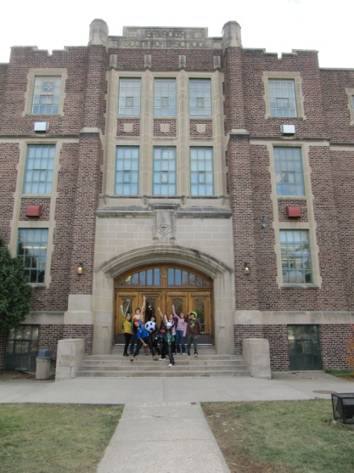Example #6: While she was teaching at Balfour, Ms.C’s Calculus class was standing outside of the school for the Halloween class picture. Ms. C looked up at an angle of elevation of 67˚ and saw a UFO approaching the school. If the UFO is at a height of 231 m, how far is the UFO away from Ms. C along her line of sight?

[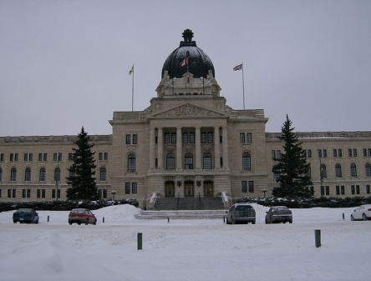](http://upload.wikimedia.org/wikipedia/commons/d/df/Sask_Legislative_Bldg.jpg)Example #7: A person leaves the front steps of the parliament buildings in Regina, walks 35 m North, turns to the right and walks East for a while and then stops. The angle between his original path going north and the line that now connects where he stopped and the front steps of the parliament building is 50˚. How far is he now from the front steps of the parliament building?

Example #7: What is the sin90? What is the cos90? <http://zonalandeducation.com/mmts/trigonometryRealms/introduction/rightTriangle/trigRightTriangle.html>

2.4 Assignment P95 # 4ii, 5ac, 6ac, 7ac, 8ac, 9 a, 10ab, 11, 12, 13, 14, 15

One or more of 17 & 18

2.5 Assignment P101 #3ac, 4ac, 5ac, 6-12

One or more of 13 & 14

NOTE: COMBINE THE ABOVE ASSIGNMENT WITH the next day 2.6

2.6 Using Trig Ratios to Solve Right Triangles

In this section, we will use Sin, Cos and Tan to Solve Right Triangles. Solving a right triangle means that at the end of each question you will know the length of all three sides and the size of all three angles. We can use the following to help us solve the triangles:



Steps to Solving Triangles:

1. Label all of your given information using: angle, hypotenuse, opposite, adjacent.
2. Which information do you have numbers for? Make a list from the choices: Opposite, Adjacent, Hypotenuse, Angle. Which piece of information do you want to find first? Which formula of the following contains the information you have? 
3. Fill in the formula with information from your triangle.
4. Solve the equation you filled in. Remember: If there is a NUMBER beside the sin, cos or tan you do NOT use the shift/2nd button!!!!
5. Make sure you round the length of the side or angle size to the correct number of decimals.
6. To find the THIRD side: Use the Pythagorean theorm.
7. To find the THIRD angle: Use the 180 rule.
8. Circle all the side lengths and angle sizes that you found.
9. Redraw your original triangle and fill in all three angle sizes and all three side lengths.

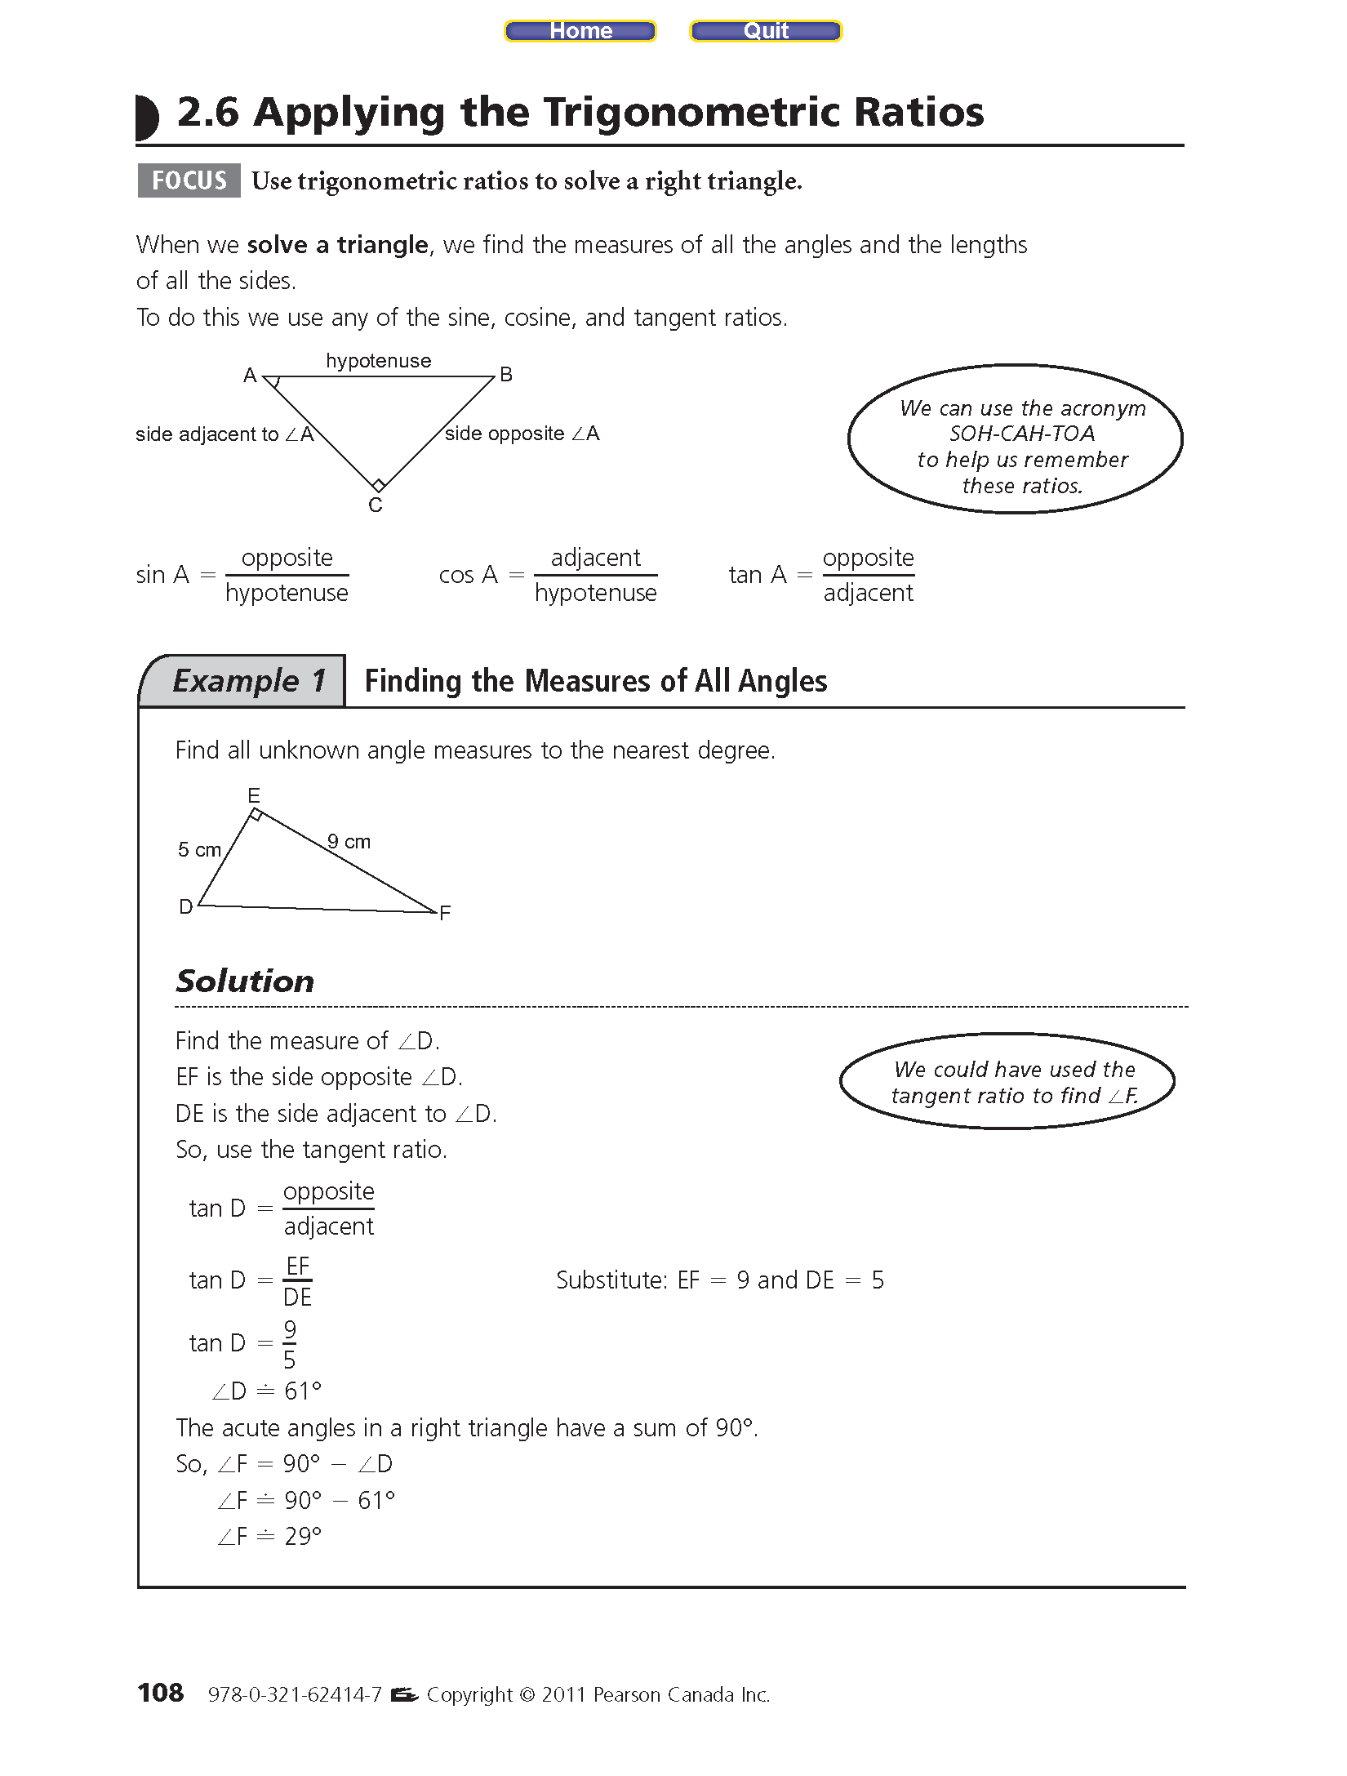Example #1: Solve the following triangles. Find side lengths to the nearest tenth and angles to the nearest degree.

a)

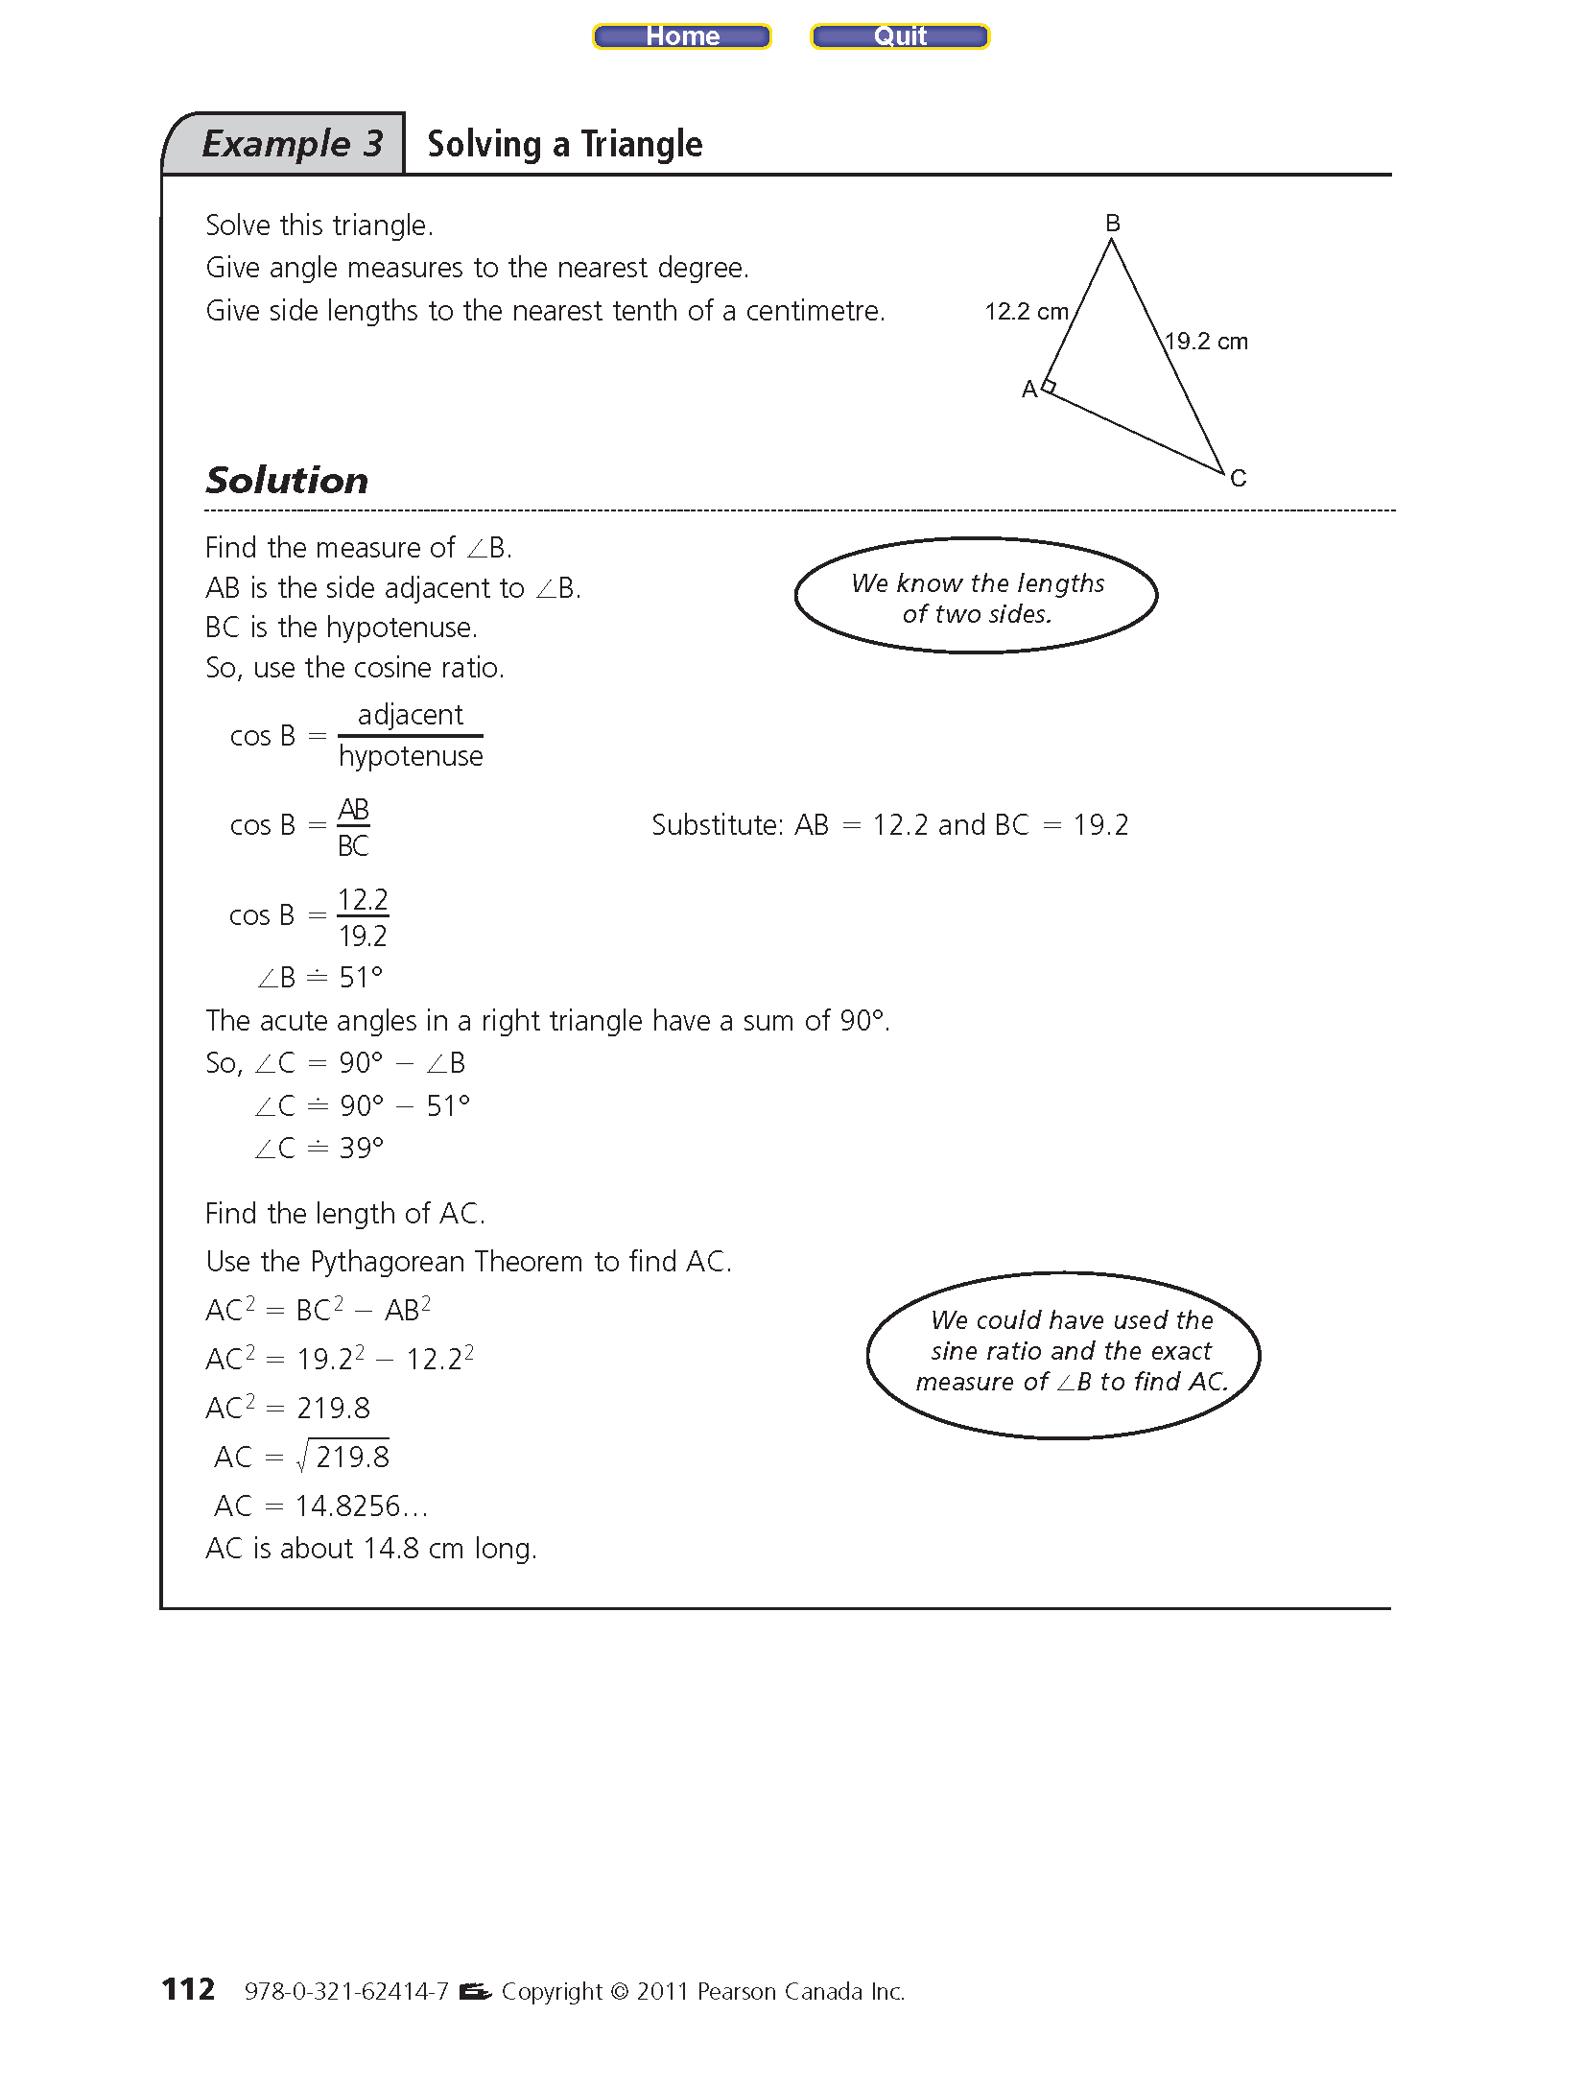b)

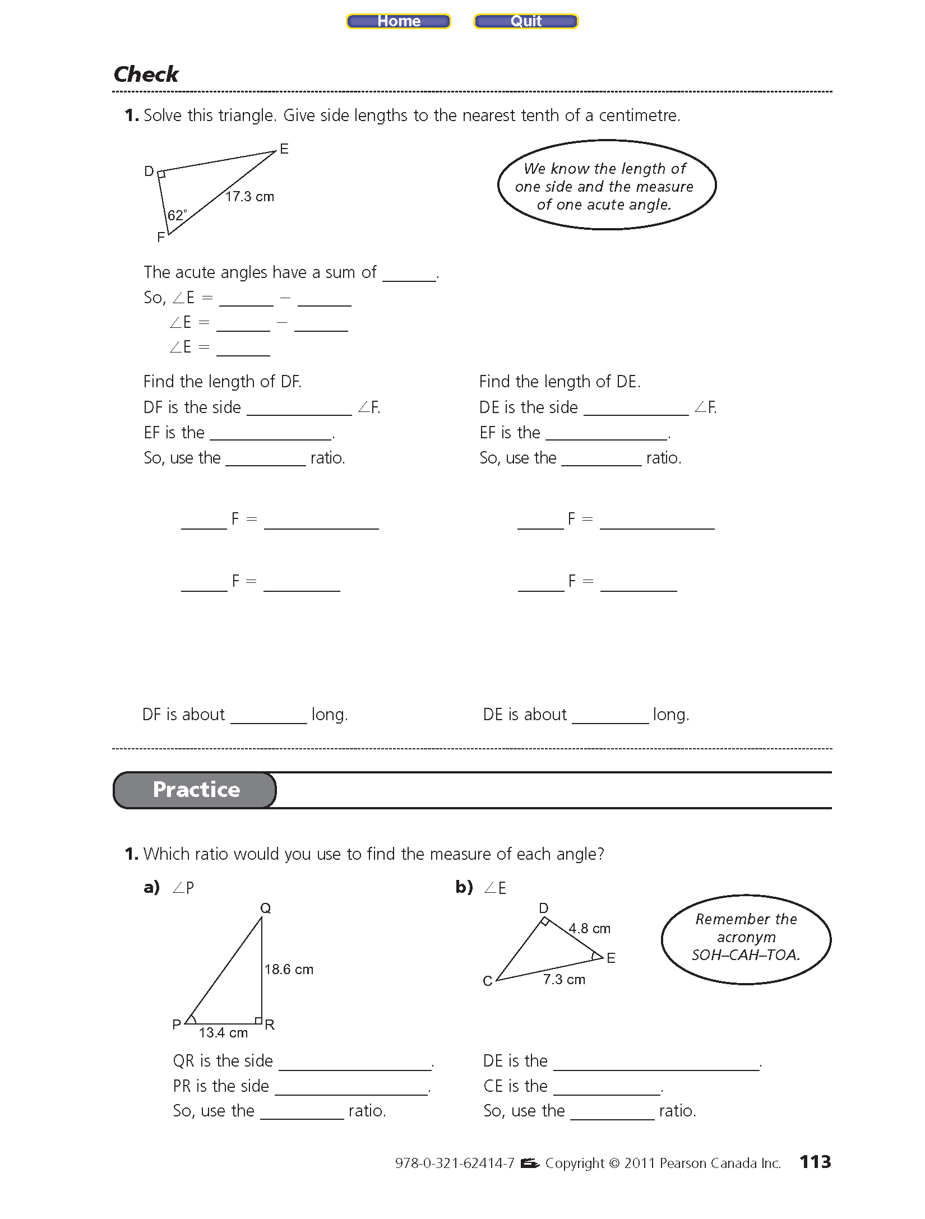

c)

2.6 Assignment P111 #6-16

2.7 Solving Problems With more than one Triangle

In this section, we will use Sin, Cos and Tan to find an unknown side or angle in situations where more than one triangle is “attached together” in a problem.

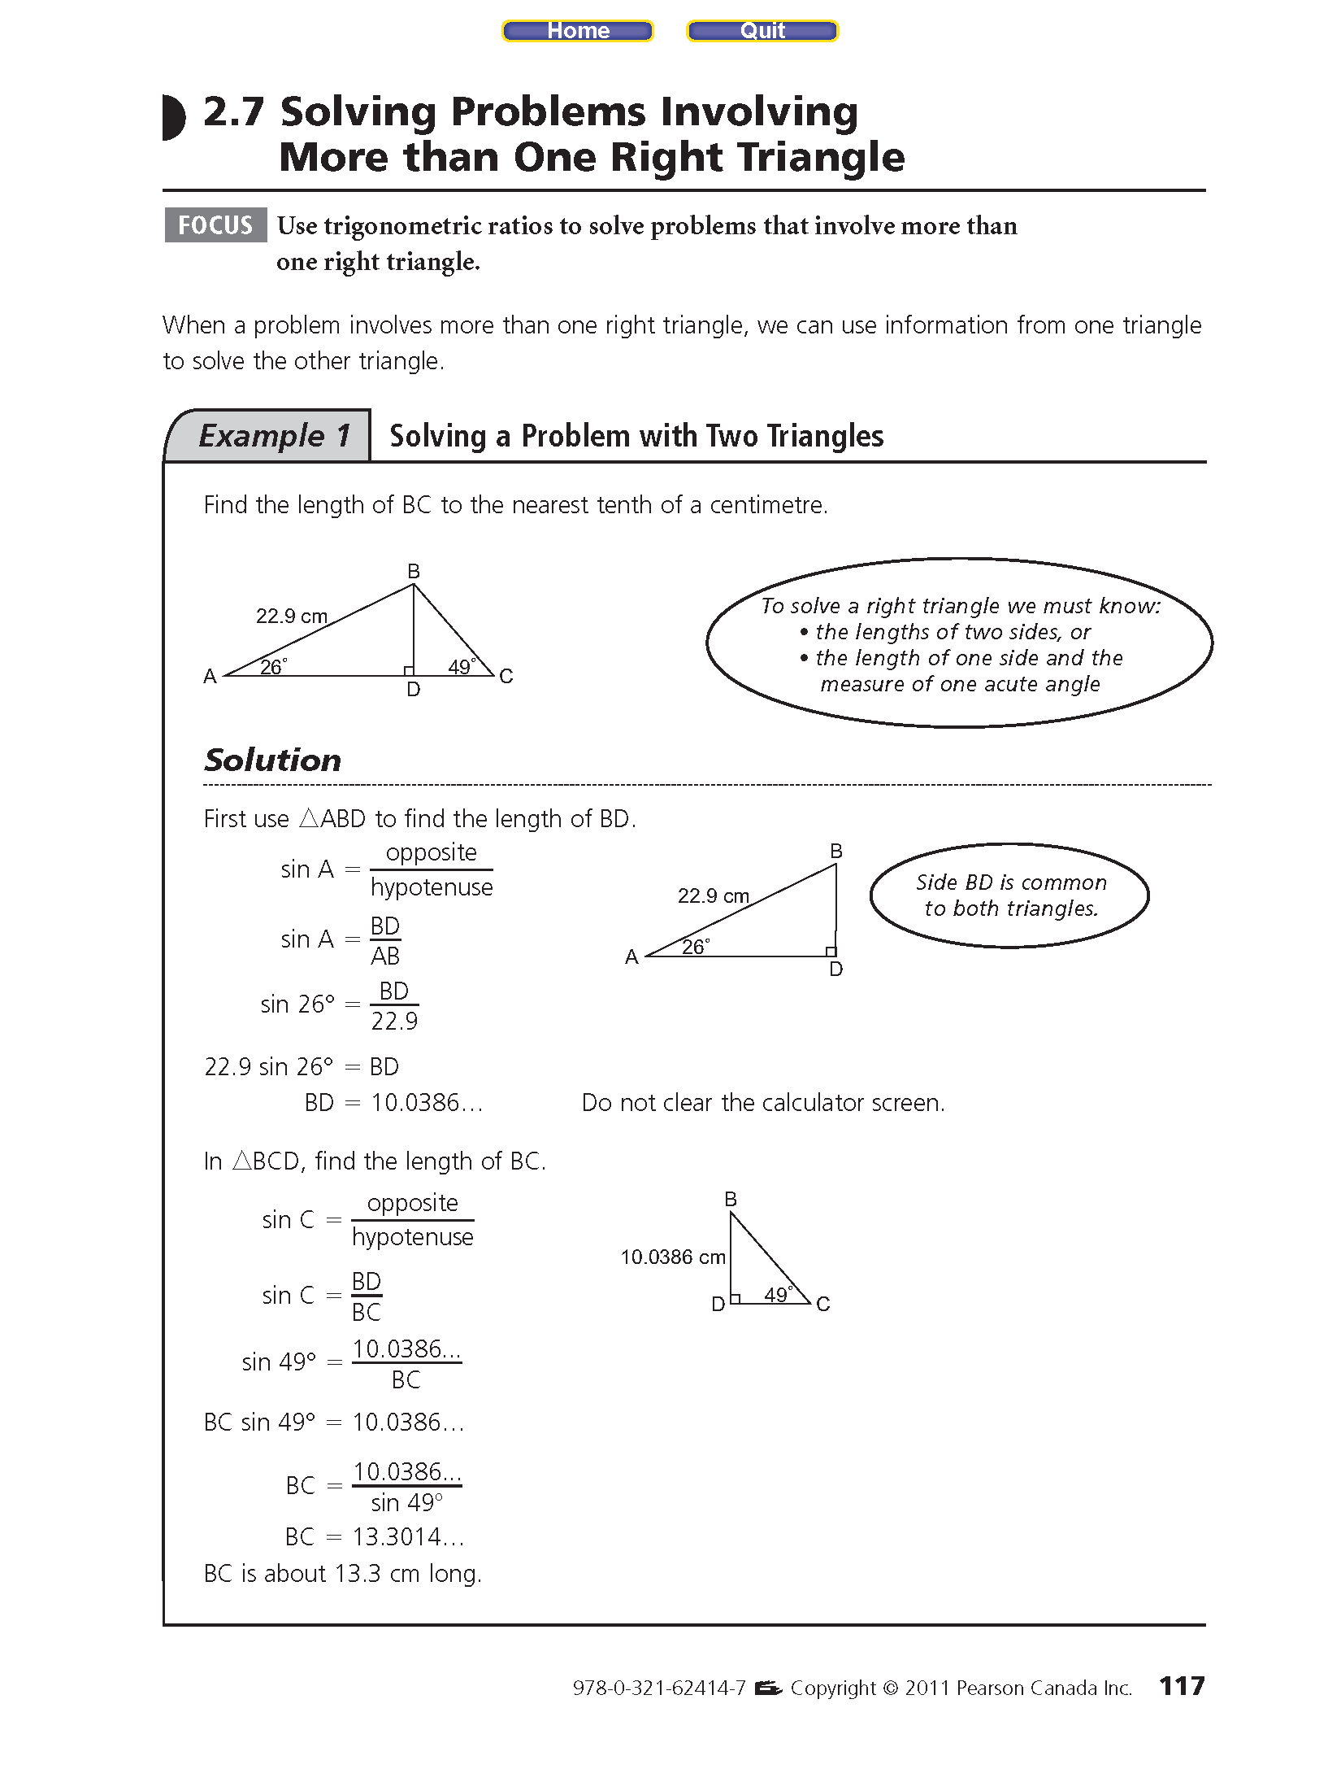Example #1: Find the length of BC.

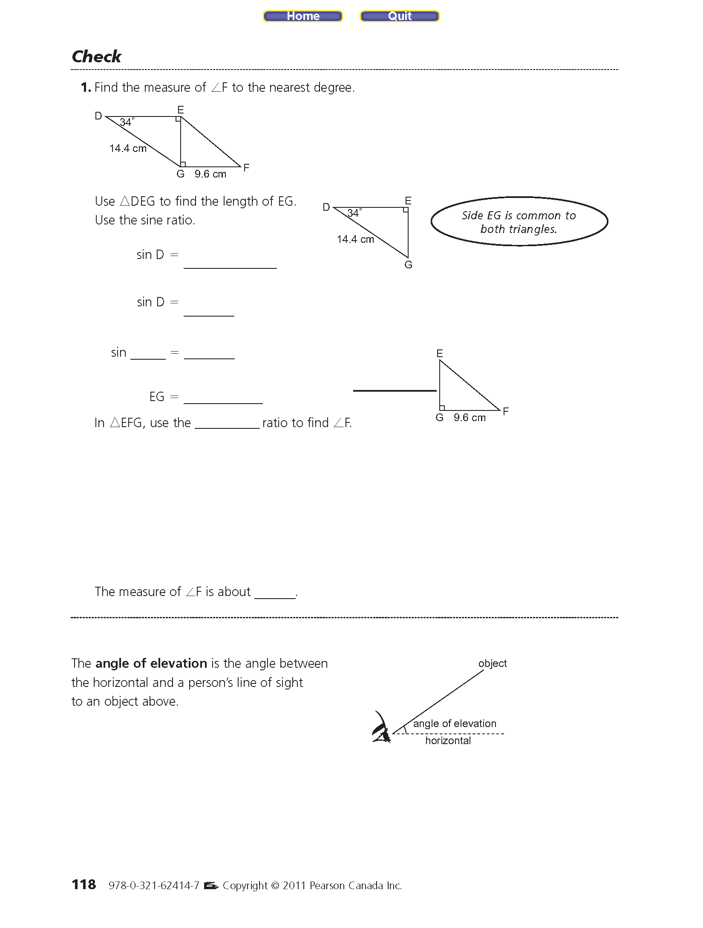Example #2:

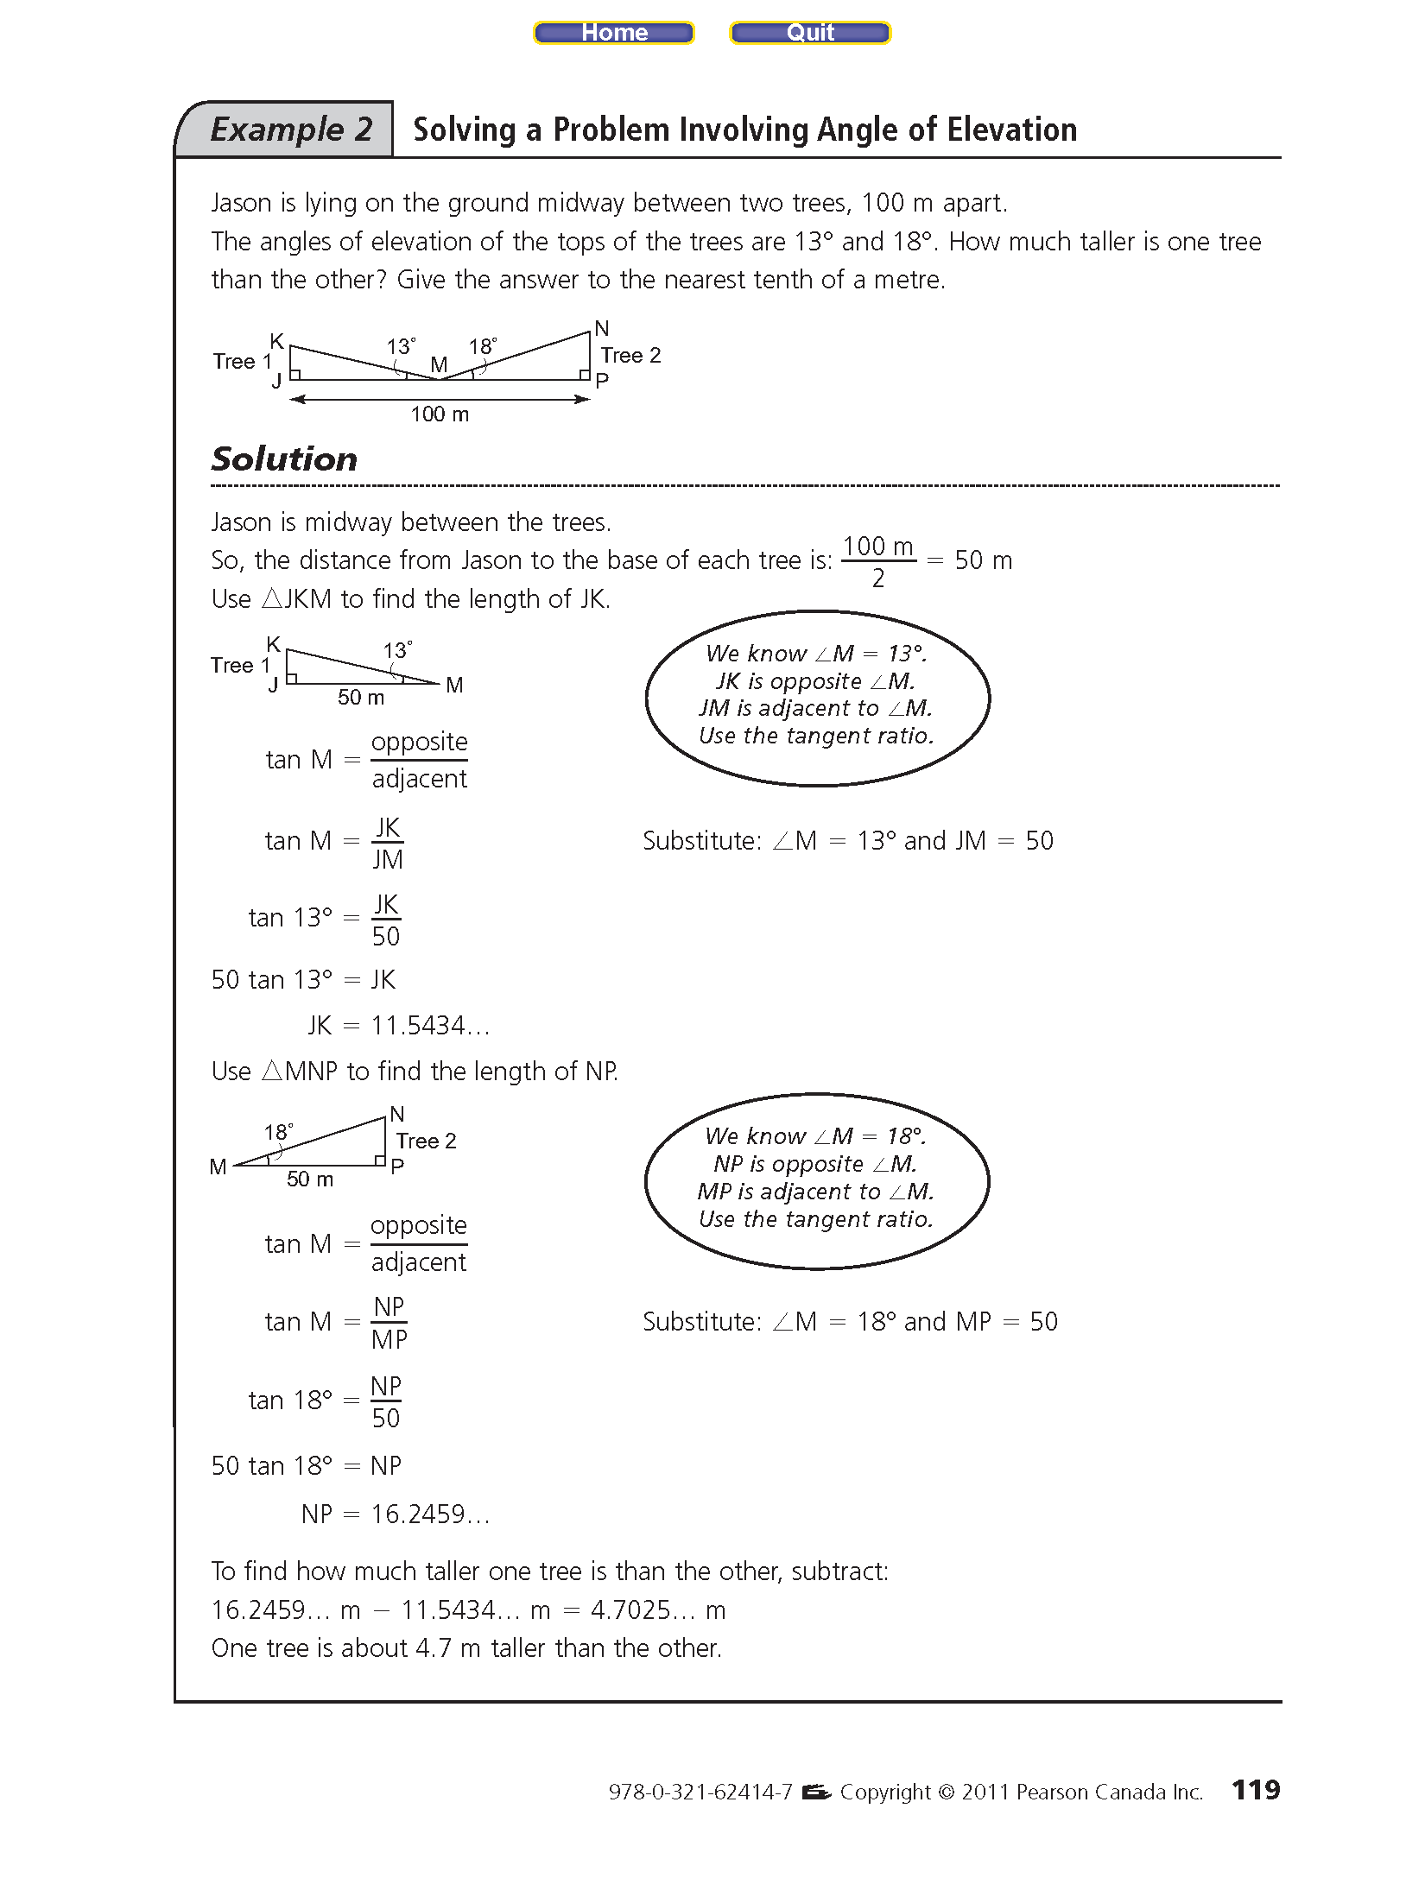Example #3:

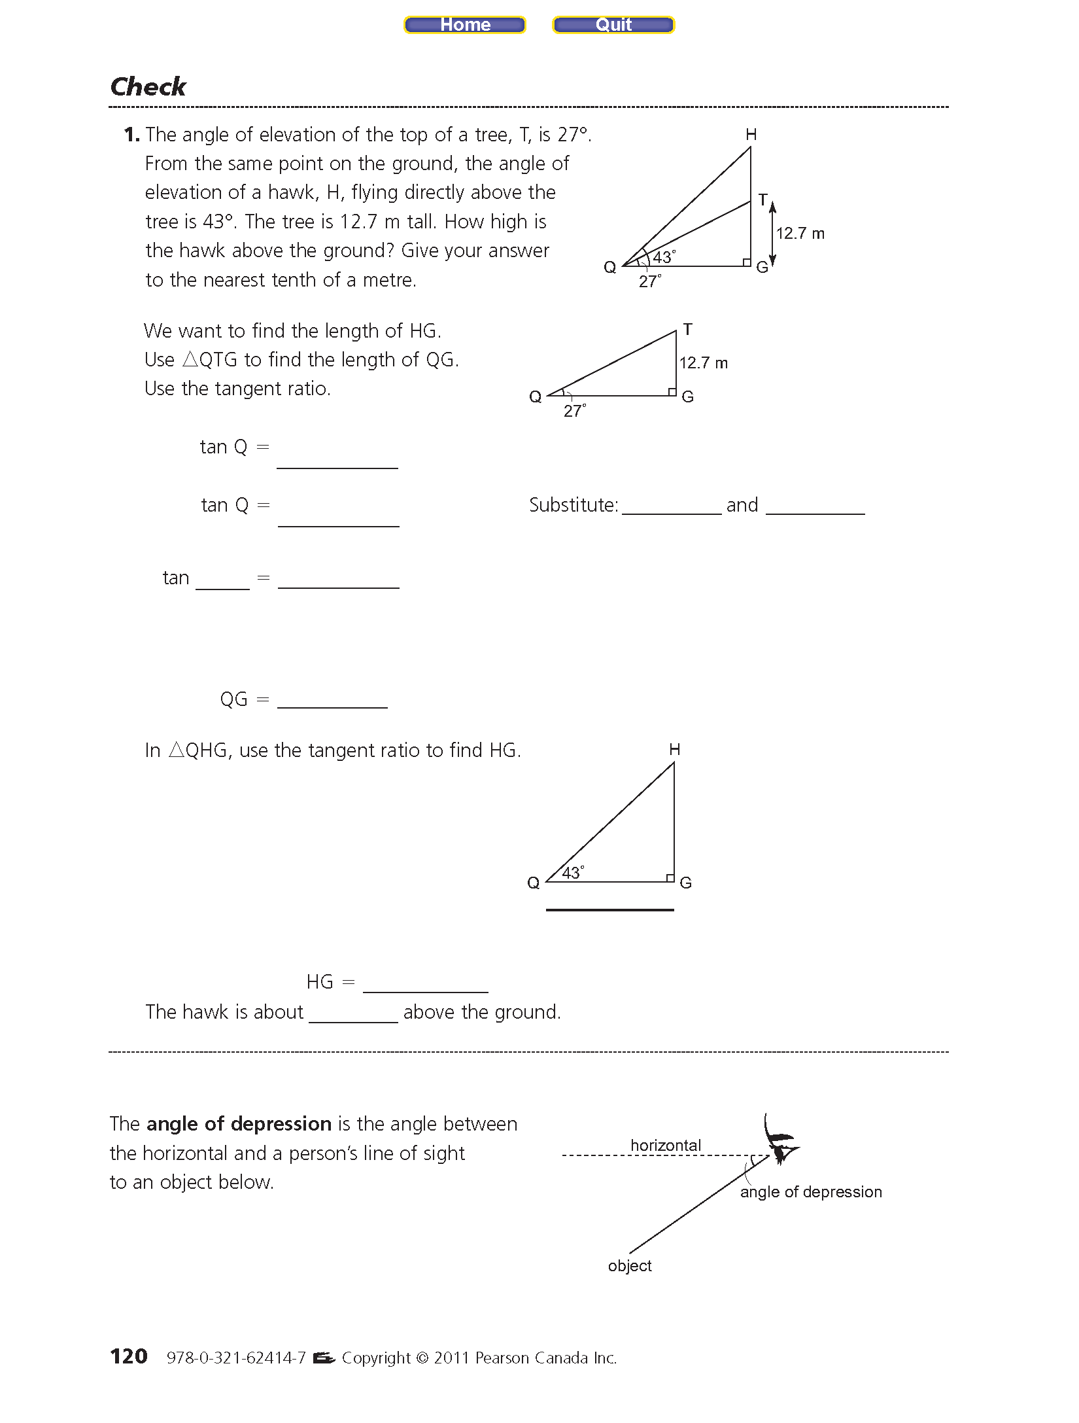Example #4:

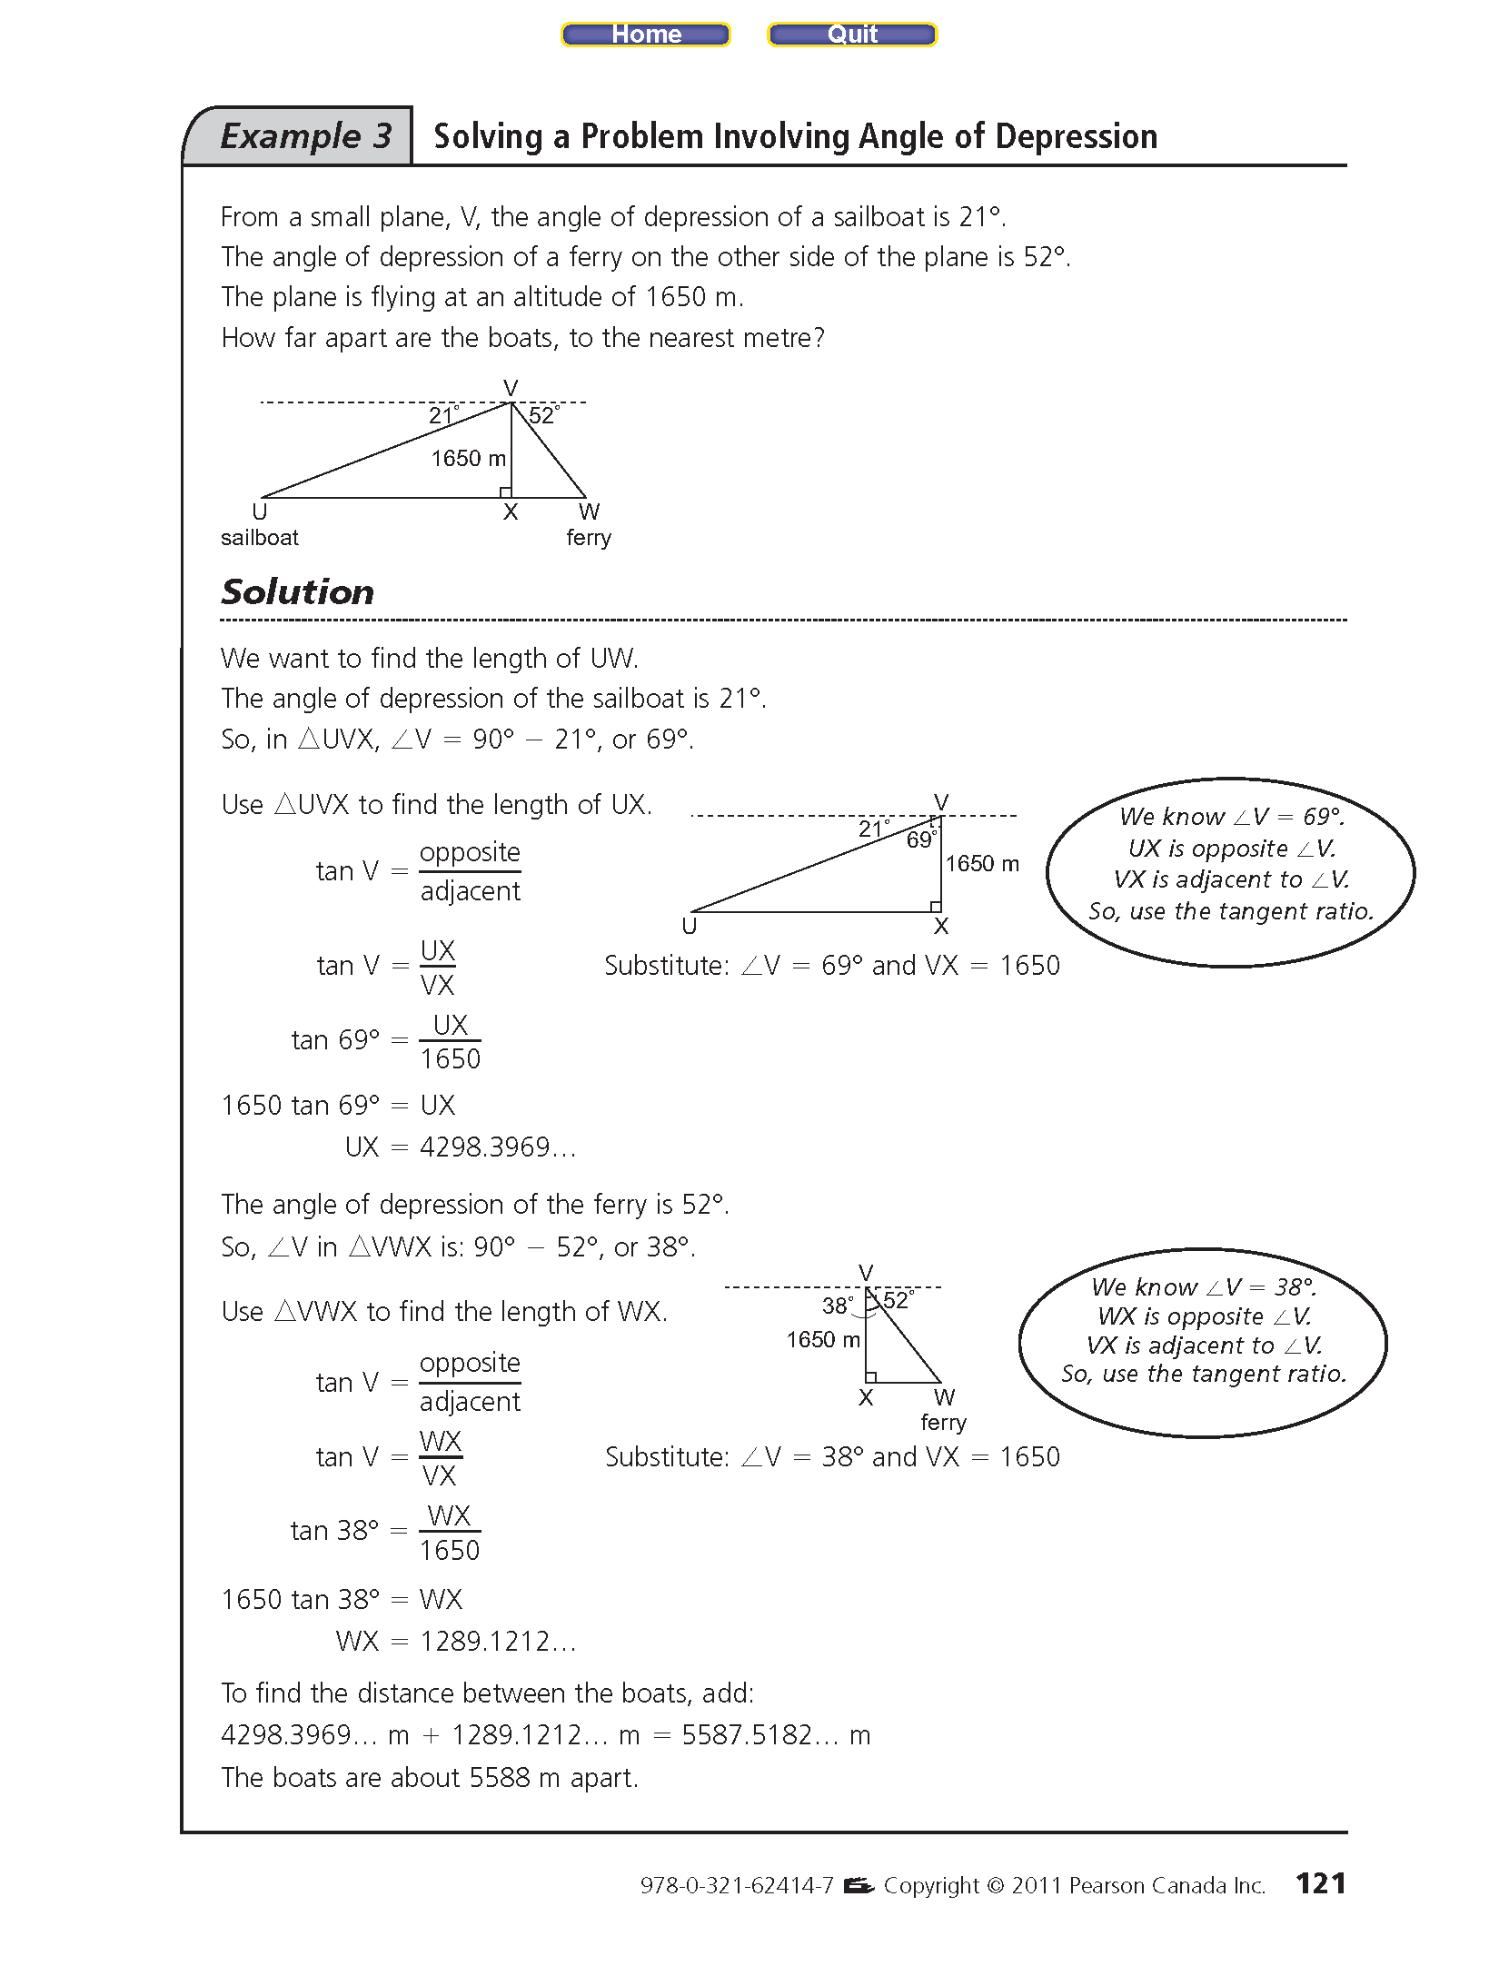Example #4:

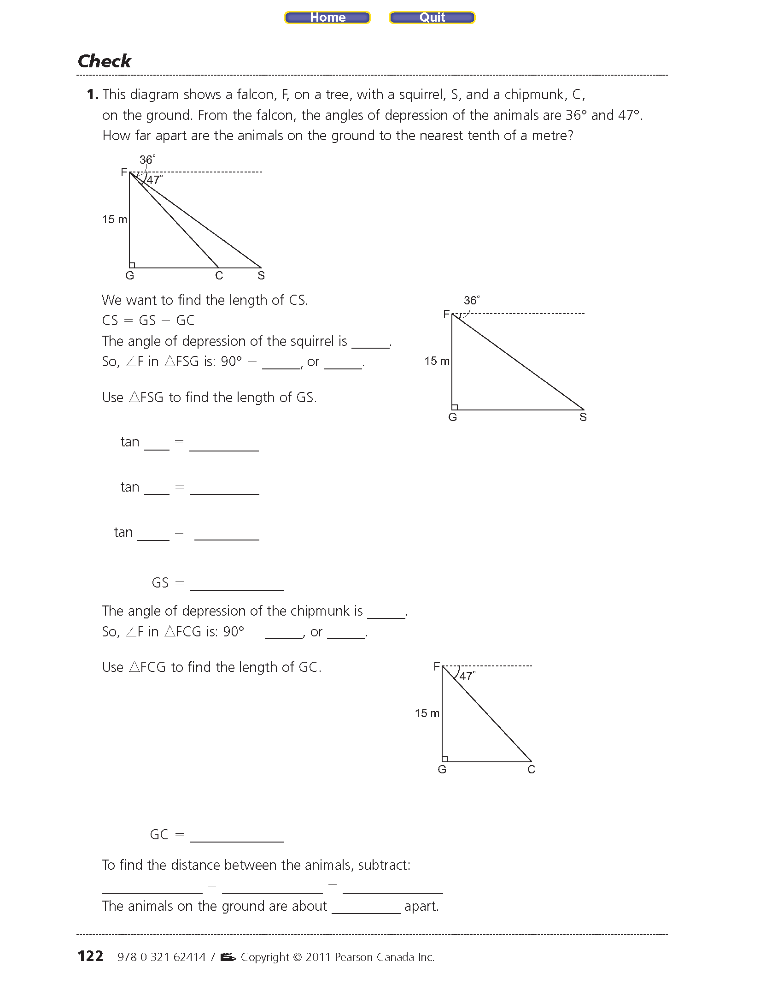Example #4:

2.7 Assignment #1: P118 3ac, 4ac, 5ac, 6, 8, 9, 11, 13, 14, 16

Two or more of 17-21