NC 5.1 Concept: #24
5.1 Representing Relations

In this section, we will review how to represent Relations in the following ways: as a set of ordered pairs, an arrow diagram, a table and a graph.
Online Video Lesson: https://goo.gl/9bZs3E
ACTIVITY #1: Turn to page 256 and complete the activity “Make Connections”
SET: A collection/list of distinct objects.
EX: A List of Teachers: {Ms. Carignan, Mr. McMillan, Mr. Adams, Ms. Moroz, Ms. Sebastian}
EX: A List of Subjects: {English, Math, Science, Wellness}
ELEMENT: What you individually call each item in the SET.
EX: Mr. McMillan is one element in the Random List of Teachers
NOTE: The list of elements in the set are usually enclosed in braces (curly brackets). The order in which
the elements are listed does not matter.
RELATION: Something that associates the elements of one set to the elements of another set

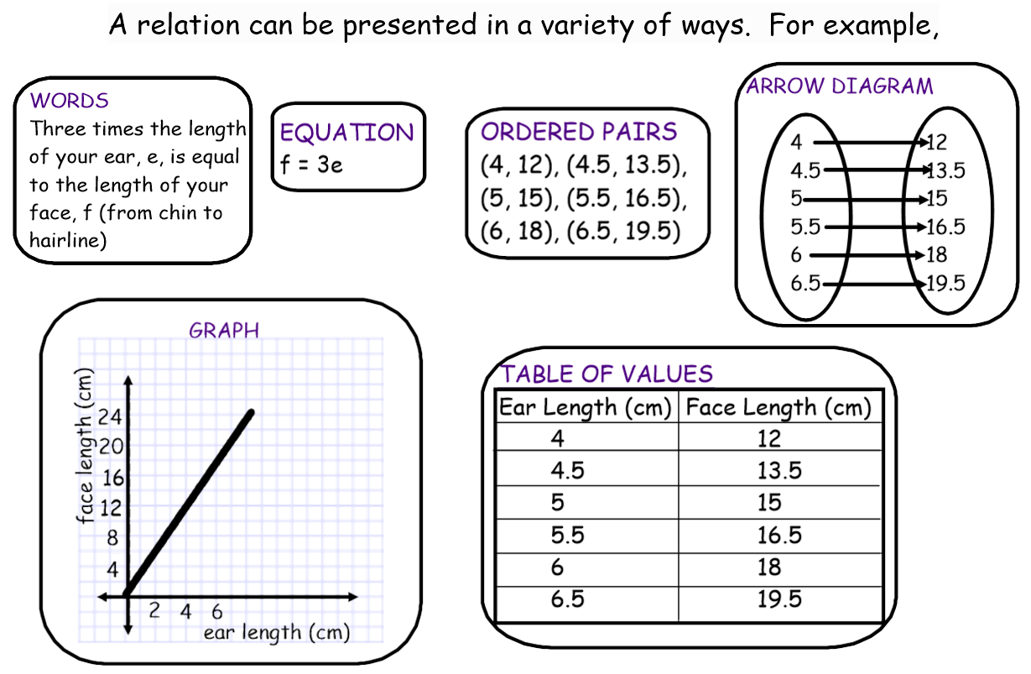
RELATIONS CAN BE EXPRESSED IN THE FOLLOWING WAYS:

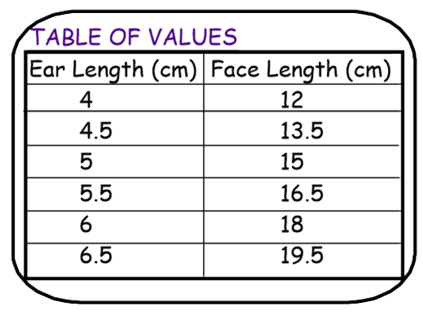

Example #1: Using the examples given in the definitions on the previous page, represent the relationship between the set of Teachers to the Set of Subjects in the following ways:
a) In a Table b) As a list of Ordered Pairs
c) As an arrow diagram
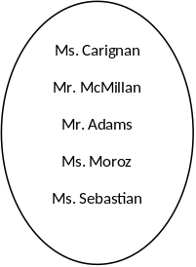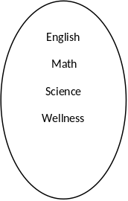
Teacher Name | Subject

When the elements of one or both sets are numbers, the relation can be represented as a bar graph.

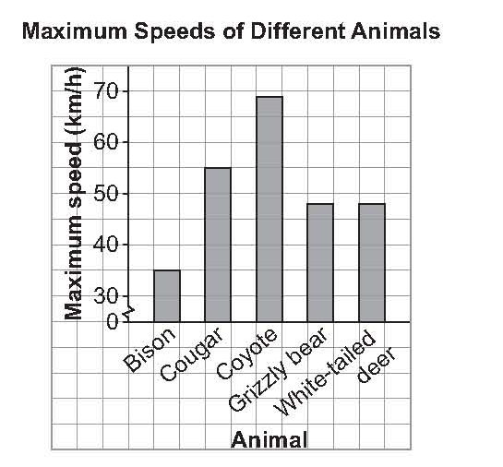
Example #2: Using the information represented by the following bar graph, re-represent the relation as:
a) A table

b) A list of ordered pairs

c) An arrow diagram

CALCULATORS NOT ALLOWED!!! Label this assignment properly!
5.1 *FA (Foundational Assign)
P 262 #4, 6, 7, 10, at least one of 12 or 13
P 167 #21

NC 5.1 Assignment for Concept #24

5.1 ULA (Upper Level Assign)

NC 5.2 Concept: #24 & 25
5.2 Properties of Functions

In this section, we will learn about DOMAIN, RANGE and FUNCTIONS. These are terms we use when we are dealing with questions about Relations between two Sets.
Online Video Lesson: https://goo.gl/y9MWZR

There is a special class of relations, called functions, where two quantities depend on each other in a particular way.
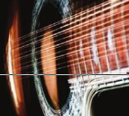
- The amount of tension on a guitar string determines the musical note played.
- The channel displayed on your television screen depends on the number you enter into the remote.

Describe other examples from your daily life where two quantities depend on each other in a particular way.
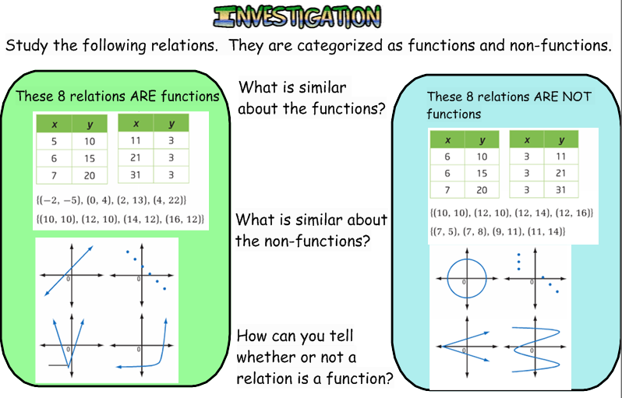
DOMAIN: The list of all elements in the first set of a relation.

RANGE: The list of all elements in the second set of a relation.

FUNCTION: A specific type of relation that occurs when each element in the DOMAIN is associated with exactly one element in the range. This means that you don’t see any repeated elements in the first column of a table, in the first numbers of a set of ordered pairs, or more than one arrow coming from any element in the first oval of an arrow diagram.

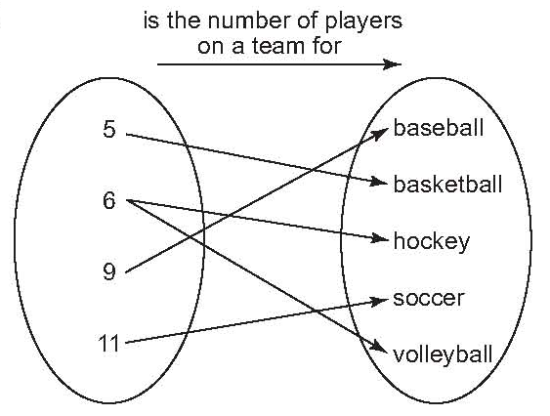
Example #1: Answer the following questions using the following Arrow Diagram,

a) State the Domain

b) State the Range

c) Is the given relation is a function? Why or why not?

Example #2: The following list of ordered pairs describes the relationship between certain months and number of students in Ms. C’s Math 10 class that have their birthdays in that month.

{(January, 4), (February, 7), (March, 3), (April, 4), (May, 6)}

a) State the Domain

b) State the Range

c) Is the given relation a function? Why or Why not?

Example #3: Rewrite the ordered pairs in Example 2 by exchanging the Domain with the Range.

a) What is the new Domain?

b) What is the new Range?

c) Is the new Relation a Function? Why or why not?

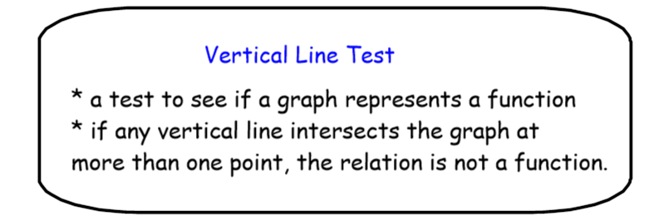

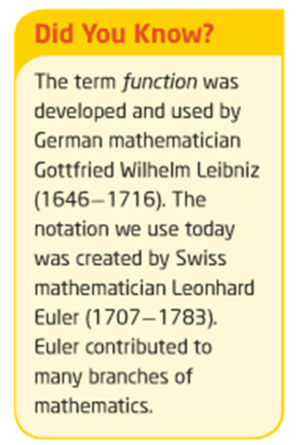
Example #4: For each pair of relations, decide which relation is a function and which relation is not a function. Explain your choice.

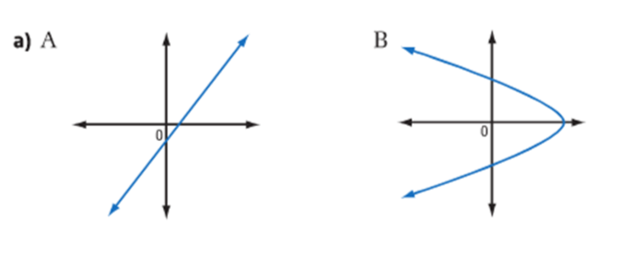

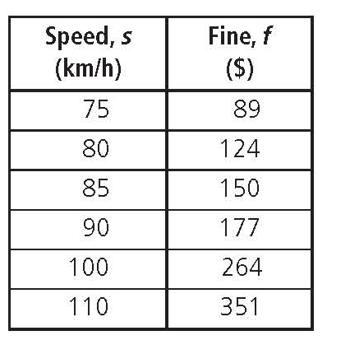
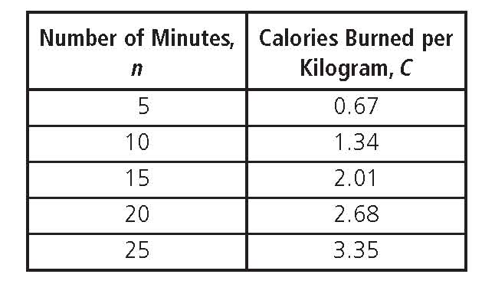
Example #3: The following table shows the fines for speeding in a 60 km/h zone:
a) What is the Domain?

b) What is the Range?

c) Is the relation a function? Why or why not?

CALCULATORS NOT ALLOWED!!! Label this assignment properly!
5.2 *FA (Foundational Assign)
P 270 #4, 5, 10 11, 12, 13
Extra questions in this handout (do on looseleaf) (Omit 1F for now)

NC 5.2 Assignment for Concept #24 & 25

5.2 ULA (Upper Level Assign)

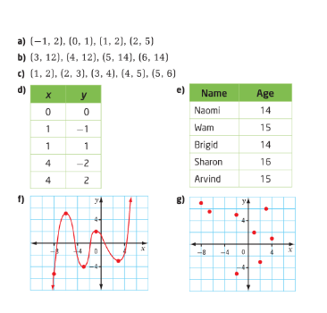
- Determine whether each relation is a function or is not a function. Give a reason for your answer.

- a) For above question 1d) identify the domain and the range.
b) For above question 1g) identify the domain and the range.

NC 5.2Cont. Concept: #24 & 25
5.2 Cont. Properties of Functions

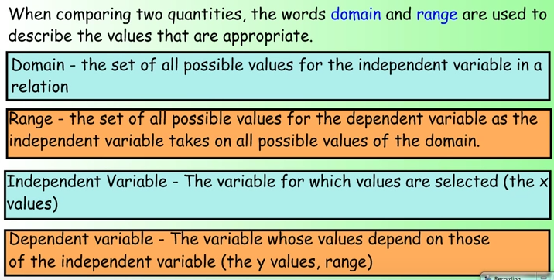
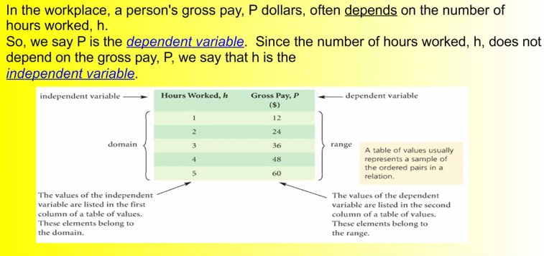

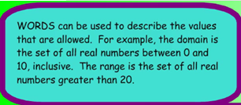
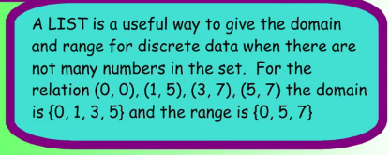
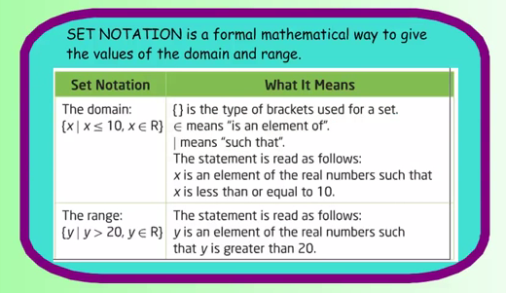
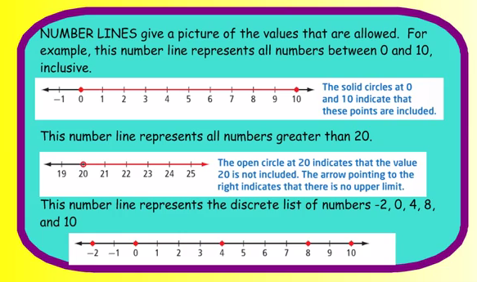

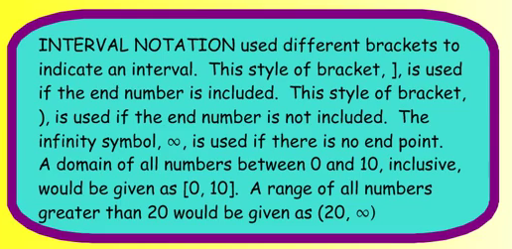

Example #1: State the domain and range of the following using two different notations.
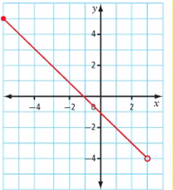

Is a list of numbers in {} a suitable way to list the domain and range for this function? Why or why not?

Example #2:
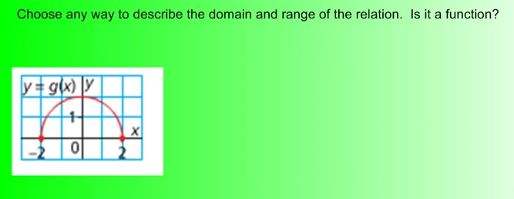

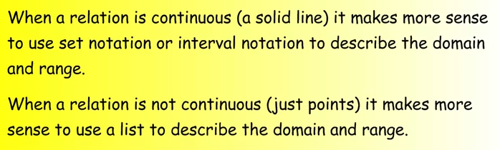

Example #3:
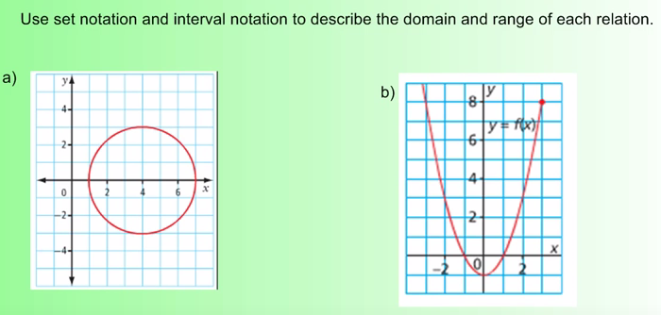

i) Is this relation a function? i) Is this relation a function?

ii) What would the domain and range be if the graph had an open circle at the right end of the graph?

iii) What would the domain and range be if the graph had an open circle at the both ends of the graph?
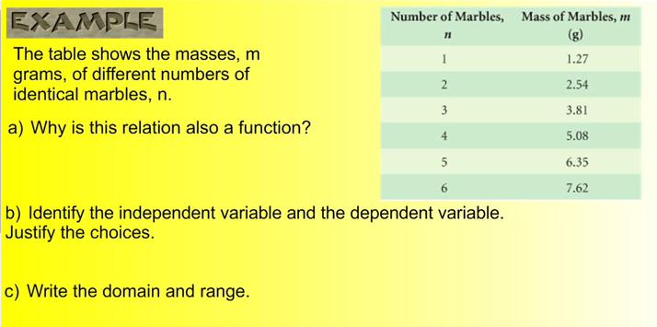

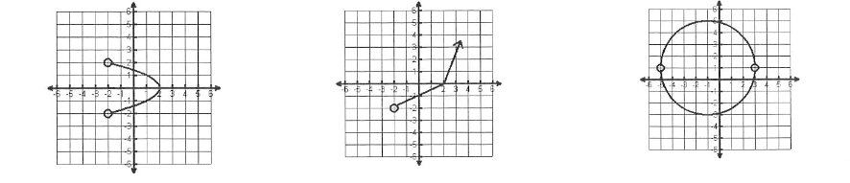
State whether the following are functions and give the domain and range in both interval and set notation.

CALCULATORS NOT ALLOWED!!! Label this assignment properly!
5.2 CONT *FA (Foundational Assign)
Question 1F from previous handout assignment
ASSIGNMENT AS FOLLOWS IN HANDOUT (do on looseleaf)

NC 5.2 Cont Assignment for Concept #24 & 25

5.2 ULA (Upper Level Assign)

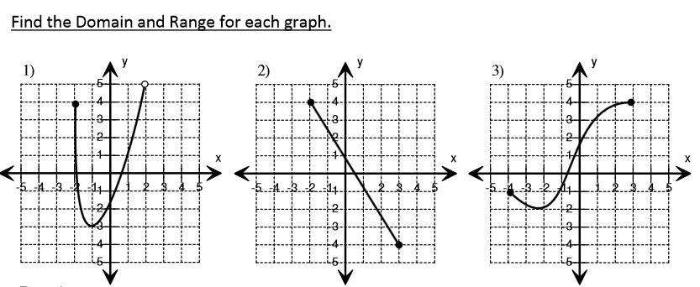
ANSWER USING INTERVAL NOTATION: Is the graph a function?

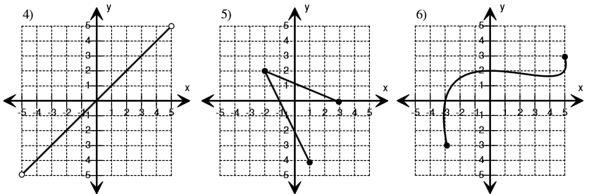

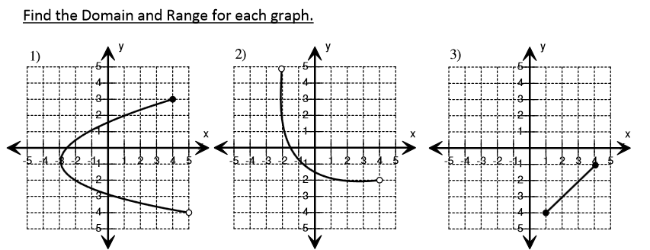
Give your answer in SET NOTATION FORM.

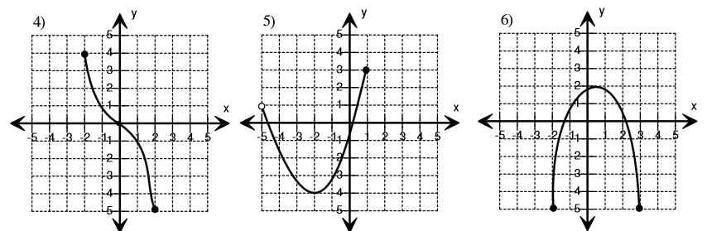

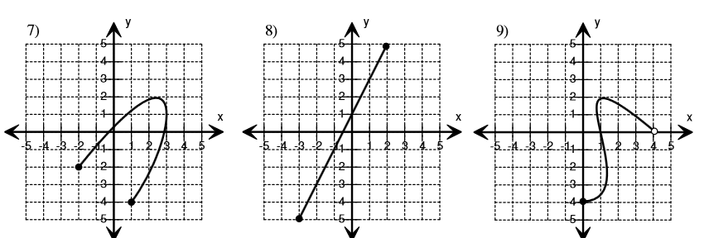

- Explain your choices.

NC 5.2 Concept: #26
5.3 Interpreting and Sketching Graphs

In this section we will learn how to describe what is happening in a given graph as well as sketch a possible graph for a given situation.
Online Video Lesson: https://goo.gl/qE12U8
Example #1: In math, a graph provides much information.

This graph shows the depth of a scuba diver as a function of time.
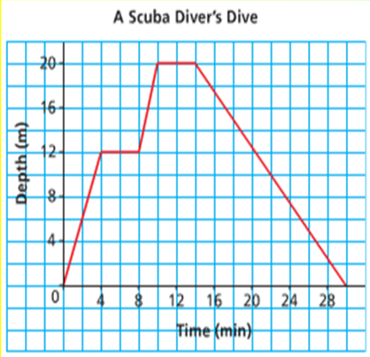
How many minutes did the dive last?

At what times did the diver stop her descent?

What was the greatest depth the diver reached? For how many minutes was the diver at that depth?

What is the domain?

What is the range?

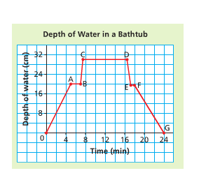

This graph shows the depth of water in a bathtub as a function of time.
- What does each segment of the graph represent?

- Compare your description with that of your partner. Are both your stories the same?

- Should they be? Explain.

- What is the domain and range?

Sketch a graph to represent this situation:
- You put the plug in the bath and turn on the taps.
- Then you leave the bathroom and return to discover that the bath has overflowed.
- Then you turn off the taps and pull out the plug to let out some water. You put the plug back in


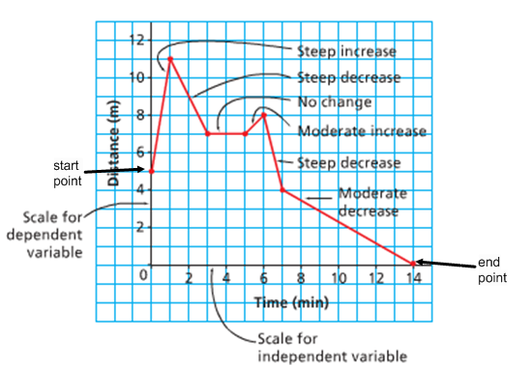
Example #2:
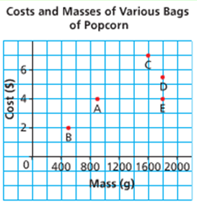
Each point on this graph represents a bag of popping corn. Explain the answer to each question below.

a) Which bag is the most expensive? What does it cost?

b) Which bag has the least mass? What is this mass?

c) Which bags have the same mass? What is this mass?

d) Which bags cost the same? What is this cost?

e) Which of bags C or D has the better value for money?

f) What is the domain and range?

Example #3:
The graph shows how the volume of water in a watering can changes over time.
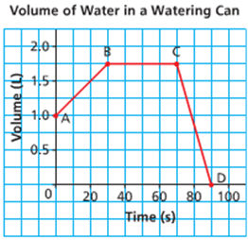
- What is the starting volume?

- Which point is this?

- Describe segment AB and what that means.

- Describe segment BC and what that means.

- Describe segment CD and what that means.

- What does point D represent?

- What is the domain and range?

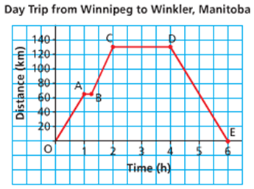
Example #4:
Describe the journey for each segment of the graph.

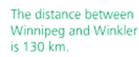

What was the total driving time? Explain.

What do you think this question means???? What are the dependent and the independent variables?

Example #5:
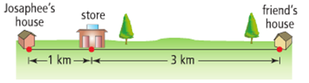
Josaphee leaves her home and walks to the store. After buying a drink, she slowly jogs to her friend's house. Josaphee visits with her friend for a while and then runs directly home. Using the distances shown, draw a distance-time graph that shows Josaphee's distance from her house. Explain each section of your graph.

CALCULATORS NOT ALLOWED!!! Label this assignment properly!
5.2 *FA (Foundational Assign)
P 281 #1, 3, 5, 7, 10, 11, 13, 16

NC 5.3 Assignment for Concept #26

5.2 ULA (Upper Level Assign)
P 282 #14, 17, 18
Extra Questions (Below)

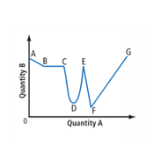
Extra Questions: (on looseleaf)
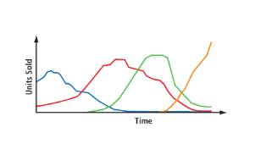
- The graph shows how quantity B is changing relative to quantity A. Describe each section of the graph as representing a constant increase, a constant decrease, an increase that is not constant, a decrease that is not constant, or no change. Explain your answers.
- Formats for distributing recorded music have changed through the years. Study the multi-line graph. Predict which line represents each format: vinyl albums, cassette tapes, compact discs, and digital downloads. Explain your choices.

