Review for Comprehensive Test #2 on Tuesday November 28, 2017
This will be a comprehensive test that covers Topics 4-6 (Ch.2, 3.3-3.8 and 5.1-.5.3) Note: An approved calculator will be allowed for the Test
Topic 4- Trigonometric Ratios Ch 2 (2.1-2.7)
Concept # | Concept | Review Questions
15 | 2.1/2.4 Correctly set up the primary trigonometric ratios (sin, cos, tan) for acute angles in right triangles (C)(Skill & Problem Solving) | Pg 124 #2 Pg 127 #1
16 | 2.1/2.4 Correctly solve for an acute angle measure in a right triangle using the primary trig ratios (C) (Skill & Problem Solving) | Pg 131 #14, 17, 18,21
17 | 2.2/2.5 Correctly solve for a side length in a right triangle (using primary trig ratios and/or the Pythagorean Theorem) & solving entire triangles (C) (Skill & Problem Solving) | Pg131 #15,16, 19, 20
18 | 2.7 Solve problems involving one or more than one right triangle (C) (Skill & Problem Solving) | Pg 131 #22 Pg 127 #6 Pg 126#23
Topic 5 – Polynomials (Multiplying and Factoring) (3.3-3.8)
Concept # | Concept | Review Questions
19 | 3.5/3.6 Correctly multiply two binomials (NC) (Skill) | Pg 252 #12 (Just expand and simplify)
20 | 3.7 Correctly multiply a binomial by a trinomial and a trinomial by a trinomial (NC)(Skill) | Pg 253 #16, 17
21 | 3.5 Correctly factor using GCF and a trinomial x²+ bx + c by method of choice. (NC (Skill) | Pg 199 #19,21
22 | 3.6 Correctly factor using GCF and a trinomial ax²+ bx + c, where a > 1 by method of choice (NC)(Skill) | Pg 200 #25 Pg 252 #14cd
23 | 3.8 Factoring using GCF and/or all of the above (including perfect square trinomials, trinomials in two variables, difference of squares) (NC)(Skill) | Pg 253 #15, Pg 200 #32
Topic 6 – Relations and Functions (5.1-5.3)
Concept # | Concept | Review Questions
24 | 5.1/5.2 Be able to express relationships in a variety of ways & correctly identify whether that relationship is a function or not with justification (NC) | Pg 326#1,3, 9 pg 459 #10,11a
25 | 5.2 Correctly determine the domain and range of linear & non-linear relations using interval notation, set notation or lists (NC) | Pg 459 #11b, #14, 16c
26 | 5.3 Sketch a graph to represent a situation, interpret a given situation, be able to identify the independent and dependent variables and determine if the data points should or should not be connected on the graph (discrete or continuous)(NC) | Pg 459 #12,13 pg 326 #6, 7  Pg 327 #8 pg 286 #1,2

Additional Questions:
- Find the domain and range of the following graphs. Are they functions or not?
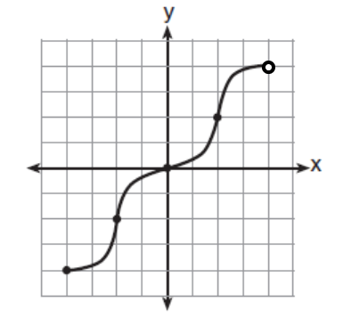
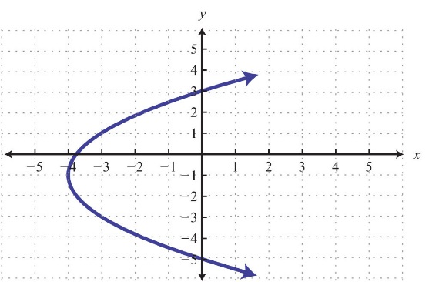
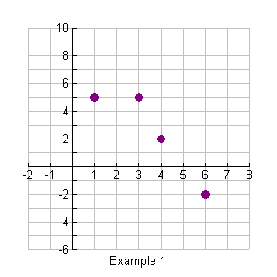
a) b) Interval Notation c) Set Notation d) Interval & Set Notation

- Draw a fully labelled graph to accompany the following situation:
Jonah is watching television. After 3 min his mom enters the room to ask him a question. He turns the volume down a bit, answers his mom, then turns the volume back up. Two minutes later, Jonah’s dad turns on the dishwasher so Jonah gradually turns up the volume. After a further 3 minutes, a commercial comes on so Jonah presses the mute button.”

