**Review for Comprehensive Test #3 on Friday Jan. 12, 2018**

This will be a comprehensive test that covers Topics 7, 8, 9 and 10  **EXTRA = Extra practice questions for this particular concept can be found on the 2nd page**

**Topic 7- Slope and Linear Relations (Ch. 6.1, 6.2 and 5.2, 5.5, 5.6 and 5.7)**

|  |  |  |
| --- | --- | --- |
| **Concept #** | **Concept** | **Review Questions** |
| 27 | 6.1 Correctly determine the slope of a line or line segment by using the graph or the formula when given two points. Explain the meaning of zero or undefined slopes and draw a line given its slope and a point on the line. **(NC)** | **Pg 353 #1,2,3 Pg 388 #1,3 Pg 391#1 Pg 388 #2 (EXTRA)** |
| 28 | 6.2 Determine whether two lines are parallel or perpendicular, explain and solve situational problems **(NC)** | **Pg 388 #6,7,8,9 Pg 353 # 7,8** |
| 29 | 5.7 & 6.1 Solve situational problems involving domain, range and rate of change of a linear relation **(NC)** | **Pg 329 #5d,e Pg 328 #15, 16b,c Pg 460 #16b,c** |
| 30 | 5.2 Be able to change between function notation and equations with two variables, and use function notation to find values. **(NC)** | **Pg 326 #4,5 Pg 327 #11**  **Pg 329 #1** |
| 31 | 5.6/5.7 Determine the intercepts of a linear function given the graph or the equation. **(NC)** | **Pg 322 #16b,17a,18i (EXTRA)** |

**Topic 8- Equations of Lines (Ch. 6.4-6.6 )**

|  |  |  |
| --- | --- | --- |
| **Concept #** | **Concept** | **Review Questions** |
| 32 | 6.4 Write the equation of a linear function in **SLOPE-INTERCEPT** form (either from given info or from a graph). Given an equation in **slope- intercept form** be able to identify the values of slope and y-intercept. Graph an equation given in **SLOPE INTERCEPT FORM**. **(NC)** | **Pg 376#2a,b, 4a Pg 389 #11, 12, 13 pg 460 #20** |
| 33 | 6.5 Write an equation of a line in **POINT – SLOPE FORM** (either from given info or from a graph). Given an equation in **POINT- SLOPE FORM** be able to identify the values of slope and one point and graph it. Graph a linear function given its equation in **POINT- SLOPE FORM. (NC)** | **Pg 389 #17, 18 Pg 376 #3ab**  **Pg 461#21a** |
| 34 | 6.5 Write an equation(In more than one form) of a line given two points on the line **( NC)** | **Pg 390#19 Pg 376 #3c** |
| 35 | 6.6 Rewrite an equation in general form ax+by+c=0 and graph a line in general form (Using the x and y intercepts and the slope-intercept method) **(NC)** | **Pg 390 #22, 25 Pg 461 #24a** |
| 36 | 6.5 Write an equation of a line that is parallel or perpendicular to a given line. **(NC)** | **Pg 389 #15, 16 Pg374 #21-25** |
| 37 | 6.4 Use an equation of a linear function to solve a situational problem. **(NC)** | **Pg 390 #27,28 Pg 376 #2 Pg 389 #14** |

**Topic 9 – Systems of Linear Relations (Ch. 7)**

|  |  |  |
| --- | --- | --- |
| **Concept #** | **Concept** | **Review Questions** |
| 38 | 7.1 Create a linear system to model a situation | **Pg 415 #1,5a pg 461 #25** |
| 39 | 7.2 Solve a system **graphically, with/without technology**, and verify the solutions | **Pg 415 #3, 5b Pg 461 #26 Pg 452 #7 (also verify the solution)** |
| 40 | 7.4 Solve a system **algebraically** using **substitution and/or elimination** verify the solutions | **Pg 453 #10 pg 461 #29** |
| 41 | 7.6 Determine the number of solutions for a linear system | **Pg 461 #31 Pg 454 #20 Pg 455 #2,3** |

**Extra Practice Questions:**

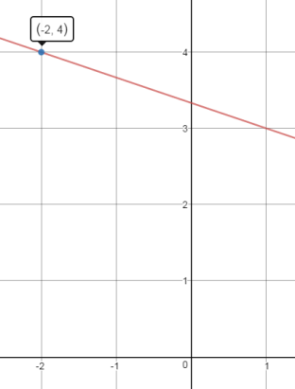**Concept #27** 1) What is the slope of: a) a vertical line? Explain why? b) a horizontal line? Explain why? **Answer: a) undefined b) zero**

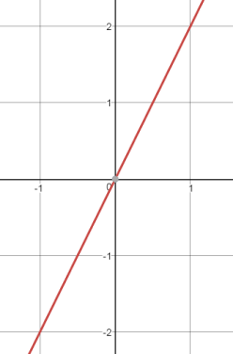**Concept #27** 1) Draw the following lines

a) A line that passes through ( -2,4) and has a slope of  Answer(a) Answer (b)

b) a line that passes through the origin and has a slope of 2

**Concept #31** 1) Determine the coordinates for the x and y intercepts for each of the following linear equations

a)  b) c) x = -6 d) y = 4 **Answers: a) (-2,0) and (0, -14) b) c) (-6,0) and y-int does not exist d) x- int does not exist and (0,4)**