FORMULA SHEET & SCRAP PAPER

**FORMULAS:**

$a^{2}+b^{2}=c^{2}$ $m=\frac{rise}{run}$

**SOH CAH TOA $m=\frac{y_{2}-y_{1}}{x_{2}-x_{1}}$**

$\sin{θ}=\frac{opp}{hyp}$ y = mx + b

$\cos{θ}=\frac{adj}{hyp}$ Ax + By + C = 0

y – y1 = m(x – x1)

|  |  |  |  |
| --- | --- | --- | --- |
| To the power 2  (Squared) | To the Power 3  (Cubed) | To the Power 4 | To the Power 5 |
| 22 = 4 | 23 = 8 | 24 =16 | 25 =32 |
| 32 = 9 | 33 = 27 | 34 =81 | 35 =243 |
| 42 = 16 | 43 = 64 | 44 =256 | 45 =1024 |
| 52 = 25 | 53 = 125 | 54 =625 | 55 =3125 |
| 62 = 36 | 63 = 216 | 64 =1296 | 65 =7776 |
| 72 = 49 | 73 = 343 | 74 =2401 | 75 =16807 |
| 82 = 64 | 83 = 512 | 84 =4096 | 85 =32768 |
| 92 = 81 | 93 = 729 | 94 =6561 | 95 =59049 |
| 102 = 100 | 103 = 1000 | 104 =10000 | 105 =100000 |
| 112 = 121 | 113 = 1331 | 114 =14641 | 115 =161051 |
| 122 = 144 | 123 = 1728 | 124 =20736 | 125 =248832 |
| 132 = 169 | 133 = 2197 | 134 =28561 | 135 =371293 |
| 142 = 196 | 143 = 2794 | 144 =38416 | 145 =537824 |
| 152 = 225 | 153 = 3375 | 154 =50625 | 155 =759375 |
| 162 = 256 | 163 = 4096 | 164 =65536 | 165 =1048576 |
| 172 = 289 | 173 = 4913 | 174 =83521 | 175 =1419857 |
| 182 = 324 | 183 = 5832 | 184 =104976 | 185 =1889568 |
| 192 = 361 | 193 = 6859 | 194 =130321 | 195 =2476099 |
| 202 = 400 | 203 = 8000 | 204 =160000 | 205 =3200000 |
| 212 = 441 | 213 = 9261 | 214 =194481 | 215 =4084101 |
| 222 = 484 | 223 = 10648 | 224 =234256 | 225 =5153632 |
| 232 = 529 | 233 = 12167 | 234 =279841 | 235 =6436343 |

**STUDENT VERSION**

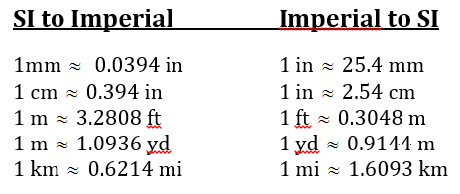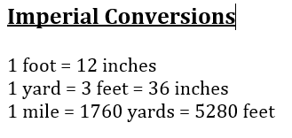

**Area**

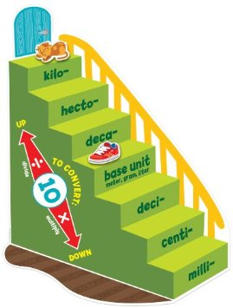Rectangle = *lw*

Circle = *πr* 2

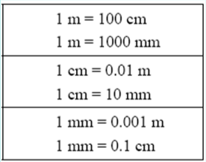Triangle = 

Parallelogram =  *bh*

Trapezoid = 

**Volume**

Prism = (*area of base*)*h*

Cylinder = 

Cone = 

Pyramid = 

Sphere = 

**Surface Area**

Prism = Sum of the areas of each face

Cylinder = 

Cone = 

Pyramid = Sum of the area of the base and the areas of the triangular faces

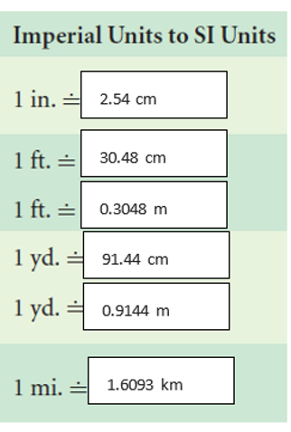Sphere = 4πr2

NOTE: C = 2πr