Campbell Collegiate
Course Syllabus

Course Name: Foundations and Pre -  Calculus Mathematics 10 PRE AP | Teacher: Mrs. Sprungala
Prerequisites: Math 9 | Teacher Email: alisa.sprungala@rbe.sk.ca
Semester: 1

General Course Description:
Foundations of Mathematics and Pre-Calculus 10 (FM10) is an introductory course offered to prepare students for one of two possible strands of high school Mathematics. This course is a prerequisite for Foundations of Mathematics 20 and Pre-Calculus 20. This course is one that will be more difficult and move at a quicker pace than Mathematics 9. Much of the material has been introduced in Math 9 and is taken more in-depth here at the grade ten level.

Mrs. Sundeen has extra information on her website – if you don’t find the help you are looking for on my site please check hers! http://sundeenfpc10.weebly.com/

Materials Required:
- Notebooks (For assignments use a graph notebook)
- Binder
- Calculator: One of the following (can’t use - “WriteView”, “Textbook Display”, “Natural Display/expression.” Or graphing calculators):
    - Sharp – EL-510, 520 or 531, Texas Instrument – TI 30X, Casio – fx260
- Pencils, erasers, ruler and highlighters
- Textbook
- You need to have a Texas Instrument Graphing Calculator in order to complete various Pre-AP portions of this course (and for each subsequent Pre-AP and AP Math course). The AP final exam in grade 12 is written using the graphing calculator for half the test and no access to any calculator for the other half.
- Below are photos of some of the types and varieties that will meet the needs of the students.
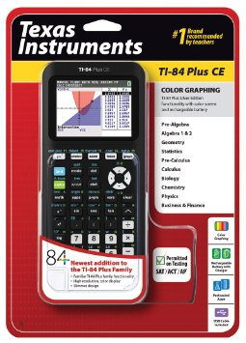
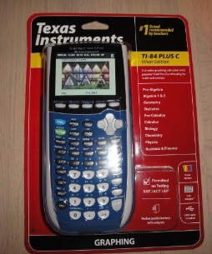
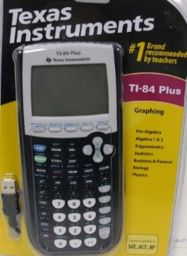

TI-84 Plus C
- The case comes in various colours
- This Calculator has a coloured screen and a rechargeable battery

TI-84 Plus CE
- The case comes in various colours
- This Calculator has a coloured screen and a rechargeable battery
- It is thinner and lighter than the previous two models
TI-84 Plus
- Regular black or Silver Case
- This calculator has a black and white screen and uses replaceable batteries

Mark Distribution:
Extension & Applications Questions: 10%
Concept Checks: 48%
Foundations Assignments: 2%
Test #1: 10%
Test #2: 10%
Test #3: 10%
Final Exam: 10%

ASSESSMENT & EVALUATION:
Please take some time to familiarize yourself with the assessment strategy used by the team of PreAP Foundations 10 teachers in all PreAP Foundations 10 courses. Here are the basics:

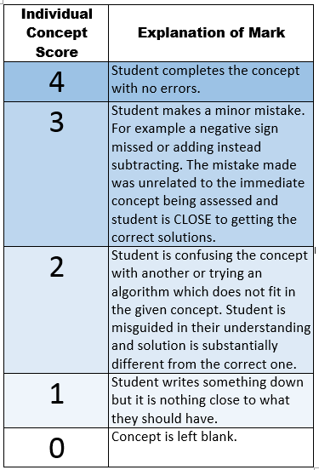
- CONCEPT CHECKS:
  - The course is broken down into 44 concepts. Approximately once a week you will have a quiz on a selection of concepts. This quiz is called a Concept Check.
  - Each concept on the quiz is tested using an appropriate number of questions that covers all aspects of the concept. Each concept is marked on a four point rubric (shown to the left).
  - If you get a score of 3 or 3.5, you made one or more “minor or silly mistakes”. This mark indicates that we feel you understand the concept but are having computational problems or are missing steps or components that need to be shown.
  - If you get a score of 2 or 2.5 we feel that you are having conceptual problems and are not fully understanding the meaning of the concept or how it is applied.
  - If you get a score less than 2 we feel that you are not currently able to demonstrate understanding of the concept. You are showing some math in an answer but it isn’t the math that applies to the particular concept being tested.
  - The Concept Check Quizzes contain the Foundational material that is necessary to be successful in this class AND in subsequent math classes. We place high value on students understanding these concepts fully and retaining this knowledge. With this in mind, there will always be two in class opportunities to assess each outcome in a Concept Check Quiz.
    - What does this look like? Concept Check #1 will test Concepts 1-5. After writing this Concept Check you will receive a mark for each concept out of 4. Concept Check #2 will test concepts 1-5 again and will test concepts 6-10 for the first time. We want you to learn from your mistakes so we give you the second try in order to clear up any problems you had the first time you wrote your quiz. We want you to be able to retain and truly understand the concept rather than memorizing. This means that we will always count your second mark as the summative mark.
    - If time permits, we may offer an out of class third attempt at concepts if appropriate.
    - Concept checks make up 50% of the course. In order to be a successful AP student it is imperative that the skills in these concepts are thoroughly understood and mastered during this course, thus the rationale for allowing for redo’s for 50% of the assessments.
NOTE: If you receive a mark less than 2 on a Concept you MUST have completed the Foundational Assignment(s) for that concept in order to be eligible to have a second attempt at the concept.
- COMPREHENSIVE TESTS
  - Rather than Unit Tests, there will be three Comprehensive Tests during the semester. The Comprehensive Tests will focus on applying the skills learned in Concept Check Quizzes. Each Comprehensive Test will be worth 10%
- EXTENSION & APPLICATION TASKS & JOURNALS
  - There will be several take home Extension Assignments and Journal writing assignments that correlate with the concepts learned in this course. There will be an increased focus on proper mathematical and algebraic procedure and setup along with an expectation of detailed written explanation of the steps and solution.
Class Late Work Policy:
It is important that students complete assignments in a timely manner as math assignments often build on the skills from previous assignments. If you are not done the assignment the day it is due, you must hand in what you have completed!

Expectations:
- If you don’t understand the way something has been taught I can usually teach it in a couple several different ways – just ask!
- My classroom is a place where people feel comfortable and accepted. Please behave in ways that help make that true.
- No phones allowed for texting, phoning, social media, games or use as a calculator (it is important that you learn to use the actual calculator that you will use during tests). There will be times when phones will be allowed during class with permission.
  - During teaching time, phones must either be left in your locker or placed in your slot in the phone holder at the front of the classroom. On most days you will be allowed to retrieve your phone after I am done teaching. This privilege will be removed if you choose to use your phone inappropriately in class.
  - Phones will NEVER be allowed during tests so be sure to always have your graphing calculator with you! I do not usually have extra calculators so you must come prepared.
- Extra help: Please always ask if you have any questions. Campbell Collegiate Math Teachers also provide a scheduled math help session every day – please check the posted sign in my classroom for times and locations
- There is no such thing as a stupid question! Ask if you don’t understand!!!!!!!
- You must come prepared for class – bring all supplies and your textbook every day.
- One of the most important things you can do to be successful in this class is to do your homework. Most days I will give you and assignment that is broken into two parts:
  - The first assignment is the Foundational Assignment (FA). This assignment contains the fundamental questions that cover the basic foundation of the concept, and will cover the minimum of skills needed to pass the class. This assignment counts for marks on a daily basis and counts towards the incentive. Completing this assignment will help you to earn up to a 60% average in this class. Assignment completion checks will be conducted on these assignments on a regular basis.
  - The second part of the assignment is called the Upper Level Homework (ULH). This homework contains questions which will provide you with practice questions that are necessary to understand if you wish to get a mark above a minimum of 60%. Homework checks on this homework will be conducted and recorded on a regular basis but will count as formative.

Math Help:
- A Math help schedule will be posted in every Math class and on my webpage. If you need help it is important that you go to these sessions.

- I use the Remind APP to send out homework assignments, answer keys to assignments and reminders about upcoming Concept Checks or Comprehensive Tests. It is very important that all students sign up for REMIND. Please use the following code to sign up now.

School Website: | School Email:
http://campbellcollegiate.rbe.sk.ca | campbellcollegiate@rbe.sk.ca
School Telephone #: | Miss Sprungala’s Website:
523-3250 | http://sprungalafpc10preap.weebly.com/

“It is hard to fail, but it is worse never to have tried to succeed.”
Theodore Roosevelt

** This page is to be completed by a parent/guardian and returned to Mrs. Sundeen **
Foundations and Pre- Calc Math 10 Parent/Guardian Form 2016/2017
I, ______________________________________________ (please print) (student’s parent/guardian), have read Mrs. Sprungala’s FPCM 10 syllabus. I understand that ______________________________________________________ (student) is responsible for adhering to the expectations and policies outlined in the course syllabus.
If I have any questions regarding the syllabus or the class, I understand that contact information has been provided above and is also available on the Campbell Collegiate website.
I understand that all attendance information, assignment information, and grades are available through the Parent and Student Portals.
If Mrs. Sundeen has questions about your son/daughters grades/behavior or just want to brag about their excellent work, she should contact (Please PRINT):
My contact information is:
Name(s): ________________________________ ___ __________________
Phone Number(s): __________________________ ____________________
Email Address(es): ________________________ ______________________
I prefer:
(daytime or evening)
(email or phone)
Thank you very much for your understanding and participation in your child’s FPCM 10 class!This will be a successful year with your support!
Mrs. J Sundeen

