7.1 Systems of Linear Equations(Concept 38)

System Of Linear Equations: A set of two or more linear equations that belong together. Linear equations each have an x and/or a y term.

In this section, we will model a situation using a system of linear equations.

Example #1: Tickets are sold for the Campbell performing arts performance. Stasia buys 3 adult tickets and 2 student tickets. She pays $31. Vincent buys 1 adult ticket and 1 student ticket. He pays $12. What is the cost of each type of ticket?

a) Choose variables to represent the problem.

b) Set up equations to represent this problem.

c) What solutions will work in both your equations?

Example #2: Which pair of values is a solution for this liner system?
X = 2y + 2
X + 2y = -6

Solution A: x = 4 and y = 1
Solution B: x = -2 and y = -2

Example #3: Campbell sold 175 smoothies to raise money for charity. A banana smoothie cost $3 and a peach mango smoothie cost $5. The school raised $625. How many banana smoothies and peach mango smoothies were sold?

a) Choose variables to represent the problem.

b) Set up equations to represent this problem.

c) What solutions will work in both your equations?

Example #4: Verify that the solution for the following linear system is x = 3 and y =2.

4x – y = 10
-2x + y = -4

Example #5: Which pair of values is a solution for this linear system?

a + b = -5
2b – 8 = a

Solution A: a = -7 and b = 2
Solution B: a = -6 and b = 1

7.1 Page 401 #5, 6, 12, ONE OF THE FOLOWING: 13, 16, 17

7.2 Solving a System of Linear Equations Graphically (Concept 38)

In this section, we will find the solution to a system of linear equations by graphing the lines

Example #1: Find the solution to the following linear system.

Verify your solution.

Example #2: Solve the following system by graphing.

x + y = 8
3x – 2y = 14

Steps For Solving By Graphing
- Solve for y in each of your original equations (this means to get the y COMPLETELY by itself)
- Graph each line on the same grid (GRAPH PAPER) using a RULER.
- Find the ordered pair (x, y) where they meet. These are the solutions.

Example #3: Solve the following system by graphing.

x – y = 3
4x + 5y = 30

Example #4: Juan tutors students in mathematics. He charges $12 for a half hour session and $20 for a full hour session. On the weekend, Juan earned $180 by tutoring 11 students. A linear system that models this situation is:

Let H = Number of students attending a half hour session
Let F = Number of students attending a full hour session

H + F = 11
12H + 20F = 180

a) Graph the linear system and find the solution.

b) How many half hour sessions and how many full hour sessions are there?

7.2 Page 409 #3ac, 4b, 5a, 6, 7ab
AT LEAST TWO OF:10, 11, 12, 13, 14,
AT LEAST ONE OF: 16, 17, 19

7.4 Using Substitution to Solve a System Of Linear Equations (Concept 39/40)

In this section, we will find the solution to a system of linear equations by using the method of substitution.

Example #1: Solve the following system using the two methods we have already learning:
x + y =5 3x – y = 3

a) By trial and error

b) By graphing.

b) By using a new method – SUBSTITUTION
2
1
- Label the equations 1 and
- Using either of the equations, solve for either x or y (get x or y by itself on one side of the equal sign). Hint: It is always easiest to pick an x or y that has no number or negative sign in front of it!!!
- Begin by using the equation from the above step. Use what is on the OTHER side of the equal sign opposite your single variable. Substitute this expression into the value of the appropriate variable into the equation you did NOT use in the previous step.
- Using this new equation, get the variable by itself. This is the answer to either the x or the y part of the ordered pair.
- Substitute this answer for x or y into either of the original equations. This will allow you to find the answer to the other variable.

Example #2: Solve the following system using substitution.
3x – 4y = -15 5x + y = -2

Example #3: Solve the following system using substitution.
3x + 6y = 4 x – 2y = 1

Example #4: Solve the following system using substitution. (Do Monday January 15)

Example #4: A math test has short answer questions and word problems. A short answer question is worth 2 marks and a word problem is worth 4 marks. There are 11 questions for a total of 30 marks. Let the number of short answer questions be x and the number of word problems be y.

a) Create a linear system to model this situation.

b) Solve this system using substitution. How many short answer questions and how many word problems are on the test?

7.4 Page 425 #4, 5, 19

AT LEAST TWO OF: 10, 11, 12, 13, 14, 15, 16, 17, 18,

7.5 Using Elimination to Solve a System Of Linear Equations (Concept 39/40)

In this section, we will find the solution to a system of linear equations by using the method of Elimination.
Steps To Doing The Method of Elimination
- Write the two equations so that one is on top of the other and they are both in the same order.
- You will add the two equations and you want one of the variables to combine to zero. To make this possible you need to have the same number with different signs in front of either both x terms or both y terms.To make this possible, you may multiply each term in an equation all by the same number, or divide each term in an equation all by the same number.
- Add the terms in the top equation to the terms in the bottom equation. Take what you get and solve for the variable (get it by itself).
- Substitute your final answer to step 3 into one of the original equations to find the answer to the other variable.
Example #1: Solve the following system using the
method of elimination.

3x + 5y = 12
7x + 5y = 8

Example #2: Solve the following system using the method of elimination.

4x + 3y = 9
2x – 7y = 13

Example #3: Solve the following system using the method of elimination.

3x + 7y = 3
4x – 5y = 42

Example #4: Solve the following system using the method of elimination or substitution. (Do Monday January 15)

Example #5: You decide to buy two different kinds of candy at the convenience store. In one bag, you put some ju-jubes and in the other licorice. The ju-jubes cost $5.50 per kilogram and the licorice $3.20 per kilogram. If a total of 1.5kg of candy was bought for $6.18, how many kilograms of each did you buy?

Example #6: You won $8000 in a lottery. You must invest part in an account earning %5 interest and part in an account earning 8% interest (both compounded annually). In one year the amount invested in the 8% account earns $90 more than the amount earned in the 5% account. How much did you originally invest in each account?

7.5 Page 437 #3, 6, 7, 12
AT LEAST TWO OF: 8, 9, 10, 11, 3, 14, 16,
AT LEAST ONE OF: 22, 24

7.6 Properties of Systems of Linear Equations (Concept 41)

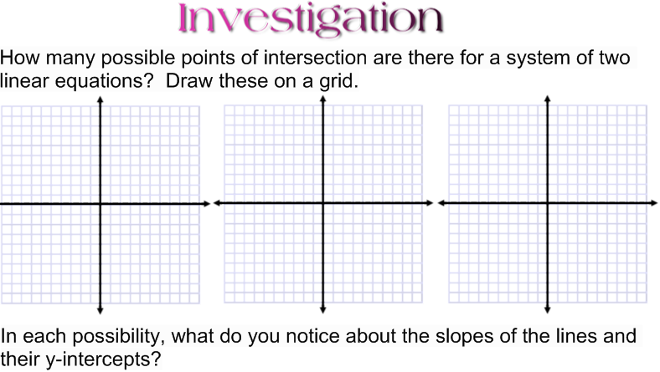

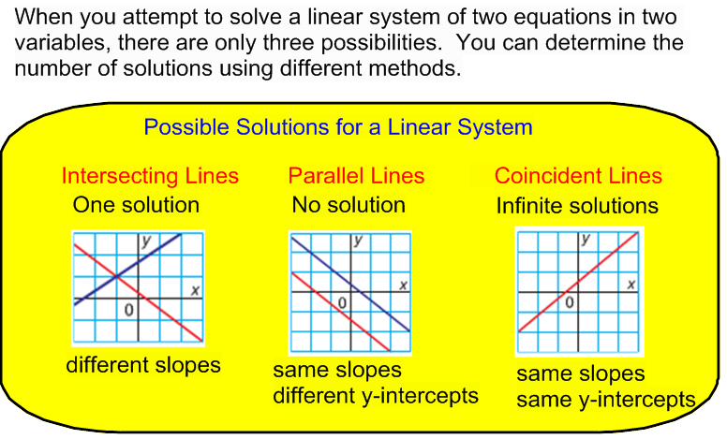
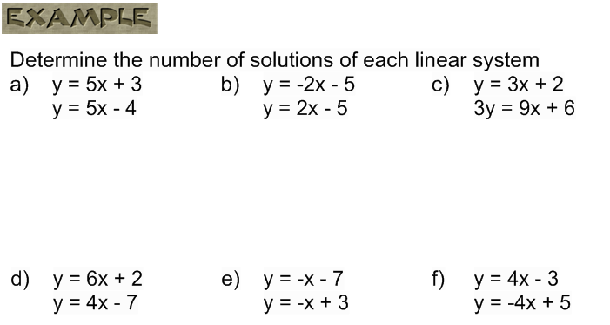

Why don't you need to identify the y-intercept to show there is only one solution?

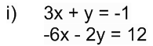

Why is it important to identify the y-intercepts when the equations in a linear system have the same slope?

7.6 ASSIGNMENT:

1. Determine the number of solutions for each linear system
a) y = x + 2 b) y = 2x – 4 c) y = 3x + 2
y = x + 2 y = x + 1 y = 3x – 5
d) y = 56 – 2x e) y = 60 + 3x f) y = -4x – 3
y = 10 + x y = 60 – 5x y = 4x – 3

2. Determine the number of solutions for each linear system (you may want to rearrange into slope-intercept form first)
a) x + 2y = 6 b) 3x + 5y = 9 c) 2x – 5y = 30
x + y = -2 6x + 10y = 18 4x – 10y = 15
d) x + 3y = 6 e) 3x – y = 12 f) x – 4y = 8
4x – y = 12 x + 4y = 20

3. Given the equation –6x + y = 3, write another linear equation that will form a linear system with:
  - exactly one solution
  - no solution
  - infinite solutions

4. Suppose you are given only the following pieces of information about a system of linear equations. Would you be able to predict the number of solutions to the system? Explain.
a) The slopes of the lines are the same
b) The y-intercepts of the lines are the same
c) The x-intercepts are the same, and the y-intercepts are the same.

5. Mark wrote the two equations in a linear system in slope-intercept form. He noticed that the signs of the two slopes were different. How many solutions will this linear system have? Explain.

6. Use substitution to show that the linear system y = 2x + 5 and 2y – 4x = -15 has no solution. How do you know there is no solution?

SOLUTIONS:
1a) infinite b) one c) zero
d) one e) one f) one
2a) one b) infinite c) one
d) zero e) one f) one
3a) Various b) Various c) Various
4) Discussion
5) One; discuss why
6) Discussion

